Kyushu Institute of Technology

Department of Applied Science for Integrated System Engineering



**BIRDS-2S Project**

**Battery Verification Report**

Laboratory of Spacecraft Environment Interaction Engineering



|  |  |  |  |
| --- | --- | --- | --- |
| **Date** | **Revision Number** | **Writer** | **Annotations** |
| 29/05/2020 | 0 | Hari Ram Shrestha, | Initial release |
| 04/01/2021 | 1 | Hari Ram Shrestha | Maya-3 & Maya-4 |
| 21/01/2021 | 2 | Hari Ram Shrestha & Yamauchi sensei | Added the discharging temperature curves |
| 21/01/2021 | 3 | Hari Ram Shrestha & Yamauchi sensei | Added the after-vacuum test discharging temperature curve |

**Table of Contents**

1. Introduction 3

2. Referenced Documentation 3

3. Test Purpose 3

a) Overall test description 3

b) Deviation 4

c) Success Criteria of cell screening 5

4. Test article(s) 5

5. Test method 7

a) Cell screening 7

i. Procedure 7

ii. Hardware configuration 8

iii. Software configuration 9

b) Vacuum Leak Test for Battery Cells 10

i. Procedure 10

ii. Configuration 10

c) Random Vibration test for Battery Cells 11

i. Procedure 11

ii. Configuration of the vibration test 11

6. Test Result 11

a) Cell Screening 11

i. Example of Battery Cell profiles 11

b) Vacuum Leak Test for Battery Cells 13

c) Random Vibration Test for Battery Cells 14

7. Selected Batteries 14

8. Thermal Exposure Test 31

# Introduction

This test was aimed to verify that individual battery cells used for BIRDS-2S (Maya-3 & Maya-4) can satisfy requirements. The battery model is SANYO eneloop plus HR-3UPT. It is a NiMH type battery(cells). The NiMH battery(cell) capacity has 1900 mAh with 1.2 V nominal voltage. Impedance and charge/discharge cycles were checked before and after the environment test. The purpose of cells verification was for selecting identical cells for packaging battery.

The aim is to minimize the state of charge imbalances that could be adversely affect the efficiency and/or protection of the battery. Battery construction and specification are shown in Figure 1-1.

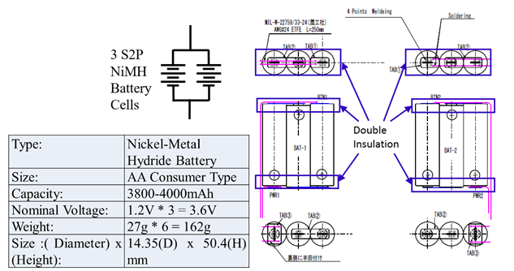

**Figure 1-1 Batteries construction and specification**

# Referenced Documentation

1. **JX-ESPC-101133-C: JEM Payload Accommodation Handbook Vol.8 Small Satellite Deployment Interface Control Document**
2. **01_BIRDS2S-EP-01: Battery Description HR Attachment**
3. **「きぼう」放出超小型衛星のバッテリ安全に関する設計・検証ガイドライン**

# Test Purpose

## Overall test description

To satisfy BIRDS-2S battery requirements, verifications shall be performed throughout this test. It includes the following steps:

* Charge and discharge cycles shall be normal, i.e., abnormal situations shall not be accepted. Abnormal situations include over-heating; packing internal impedance over-range, etc.
* Structure of batteries box shall not be modified during the test.
* Test shall be carried out at constant room temperature since batteries properties are temperature sensitive.
* The impedance verification shall be performed after charge and discharge.
* During the vacuum leak test, the pressure should be less than in pressure to 0.1 [psi] or less for 6 hours.
* For the random vibration test, the level shown by Figure 3-1 shall be followed.

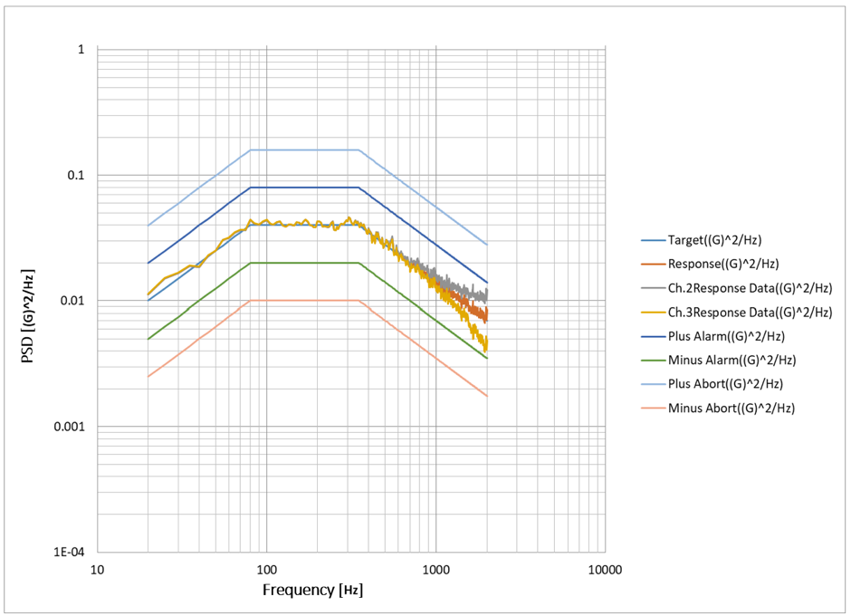

Figure 3-1 Random vibration test level (Minimum Screening Level)

## Deviation

The test shall comply with the following conditions. If any non-compliance occurs, a non-compliance report shall be written.

* + Abnormality of sensors or testing article component part.
  + Aborting test due to control malfunctioning.
  + Change any of hardware, software setup, or configuration during test. If a problem occurs and requires trouble shooting involving a configuration change (for example sensors change, component removal, etc.), then the test shall be iterated.
  + Any other test anomalies shall be reported.

## Success Criteria of cell screening

* The change of capacity before and after each environmental test should be less than 5%.
* The change of mass and open circuit voltage during before and after vacuum leak test should be less than 0.1%.
* The change of mass and open circuit voltage during before and after random vibration test should be less than 0.1%.
* Internal impedance of cell should be equal as much as possible.
* Battery temperature will not reach the **45 degree** (analysis)**.**

#### ****Selection Methodology****

* **Excluding all cells with discharged capacity less than 0.88 rated value**
* **Select six cells with the most equal internal impedance for six packs**

# Test article(s)

Test article is shown in Table 4-1.

**Table 4-1 Test articles**

|  |  |  |  |  |  |
| --- | --- | --- | --- | --- | --- |
|  | **Article name** | **Model Number** | **Manufacturer** | **Range** | **Quantity** |
| **1** | Battery cells | Eneloop  BK-3MCC | Panasonic | 1.2 V | 36 |
| **2** | FM batteries box | - | HMD | - | 3 |
| **3** | Cell switcher system | V.5 | Kyutech | - | 1 |
| **4** | Charger/Discharger system | V.5 | GW INSTEK | - | 1 |
| **5** | LabVIEW | 2015 | National Instruments | - | 1 |
| **6** | Vibration machine | 35000BD/LA36AP | EMIC | 28kN  5～2200 Hz | 1 |
| **7** | Square chamber | - | - | >1x10-4 Pa | 1 |
| **8** | Jig | C-2 | - | - | 1 |

# Test method

In the test, including the before and after the environmental test. The assembly battery (cells) will be selected after doing all the following processes. After that, we must compare and analyze steps 1 and step 5.

We conducted each test according to flowchart which is shown in Figure 5-1.

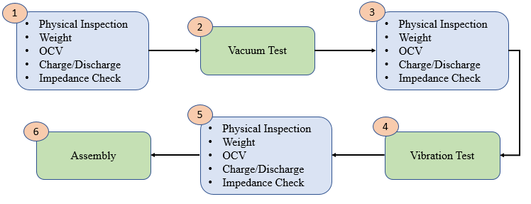

**Figure 5-1 Flowchart for screening test (Ref. [3])**

## Cell screening

### Procedure

Procedural checklist (given in Figure 5-2) was written during test for each battery cell. It includes necessary steps for the test performed. The table shall be filled out during the test. As-run test consists of 5 steps described below.

* **1st impedance measurement**

At the first, each battery cell’s impedance is measured by the two -point current voltage relationship mechanism. It is called the two-tier DC load method.

* **Pre discharge and charge**

In this step, the battery is firstly pre-discharged to 1 V, in case the batteries have any remaining charge and then fully charged until its full capacity.

* **2nd impedance measurement**

After first pre-discharge and charge cycle, each battery cell’s impedance is measured and is automatically recorded.

* **Discharge**

In this step, discharge test was conducted after each cell fully charged at the first cycle. In this case, the voltage was approximately 1.6 V for all of the battery cells. The battery is discharged until 1 V.

* **3rd impedance measurement**

After last discharge, each battery cell’s impedance is measured and is automatically recorded.

* **Post Charge**

After full discharge, each cell was charged until 1.4 V for keeping the battery at a good capacity level.

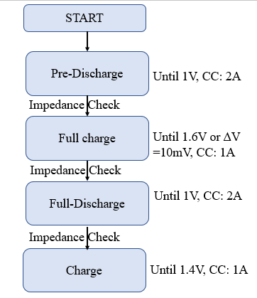

**Figure 5-2 Procedural checklist of Battery Cell screening**

### Hardware configuration

Testing setup consists of 5 main items: a wall adapter DC power supply (1), a charger/discharger (2), cell switcher system (3), a computer running a LabVIEW based program for testing control (4), and battery cells (5). Block diagram of measurement setup is shown in Figure 5-3 and real appearance of measurement setup is shown in Figure 5-4.

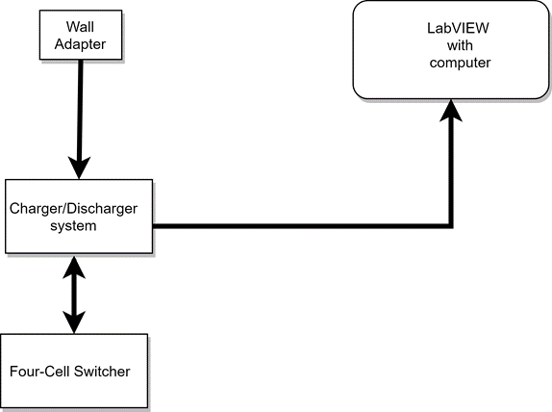

**Figure 5-3 Block diagram of hardware configuration of battery screening setup**

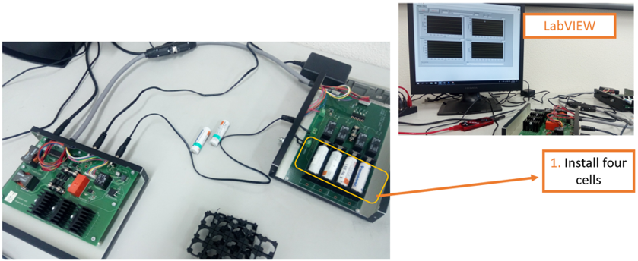

**Figure 5-4 Real appearance of hardware configuration**

### Software configuration

To run the test, a LabVIEW program was used to perform charge/discharge cycles and for battery cell impedance measurement. Interface of LabVIEW program is shown in Figure 5-4. The time was also recorded during the test. Figure 5-5 shows the testing setup as required in the LabVIEW program.

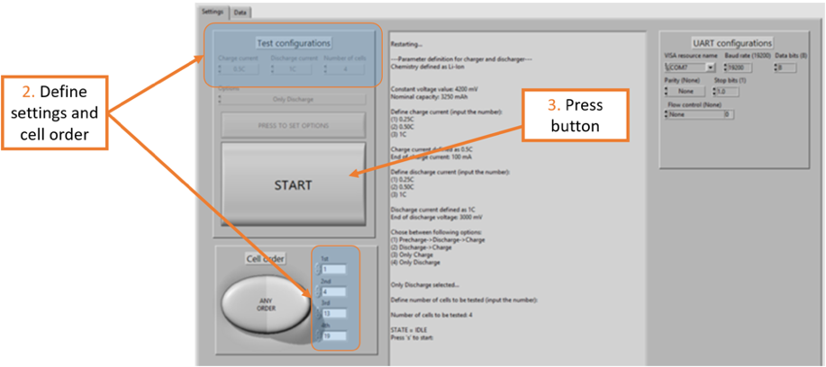

**Figure 5-5 Software configuration**

## Vacuum Leak Test for Battery Cells

### Procedure

Battery cells were left in a chamber reduced in pressure to 1x10-3 Pa or less for 6 hours. Battery cells’ mass, open circuit voltage and capacity were measured before and after the vacuum test.

### Configuration

Figure 5-6 and 5-7 show the configuration of vacuum test and battery cells.

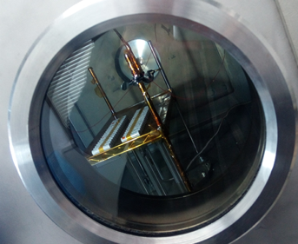

**Figure 5-6 Battery cells configuration**

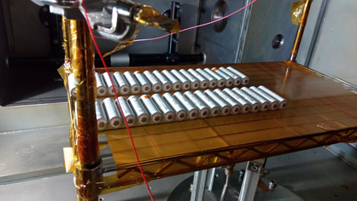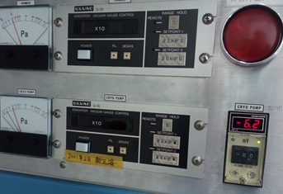

**Figure 5-7 Chamber configuration**

## Random Vibration test for Battery Cells

### Procedure

Random vibration test of battery cells utilizes the conditions shown by Table 5-1. The vibration level covers Minimum Screening Level (MSL) and battery cells’ mass, open circuit voltage and capacity were measured after the vibration test.

**Table 5-1 Random Vibration Condition (Ref. [3])**

|  |  |
| --- | --- |
| **Frequency [Hz]** | **PSD [g2/Hz]** |
| 20 | 0.010 |
| 80 | 0.040 |
| 350 | 0.040 |
| 2000 | 0.007 |
| **Overall [Grms]** | 6.1 |
| **Duration (sec)** | 60 |

### Configuration of the vibration test

Figure 5-8 show the configuration of vibration test.

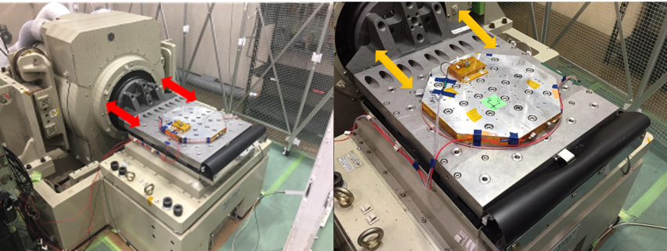

**Figure 5-8 Test Configuration**

# Test Result

## Cell Screening

### Example of Battery Cell profiles

Tested cells’ charging and discharging profiles were similar which are shown in Figure 6-1 and 6-2.

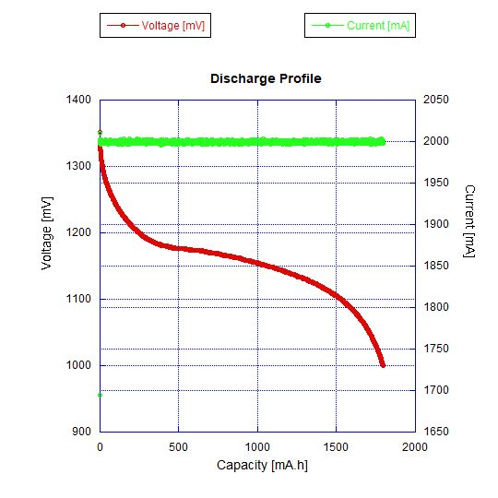

**Figure 6-1 Discharging profile for cell**

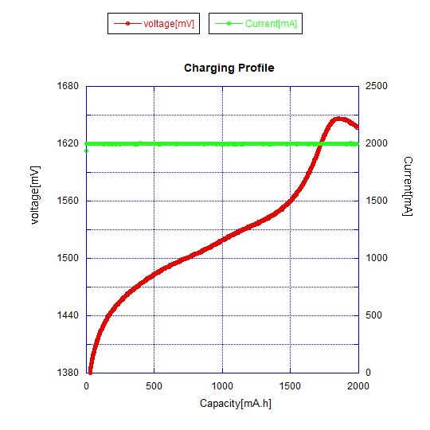

**Figure 6-2 Charging profile for cell**

## Vacuum Leak Test for Battery Cells

Table 6-1 shows the data of cells.

**Table 6-1 Comparison of Mass, Open Circuit Voltage (OCV) and Capacity before and after vacuum test**

|  |  |  |  |  |  |  |  |  |  |
| --- | --- | --- | --- | --- | --- | --- | --- | --- | --- |
| Battery No | Mass | | | OCV | | | Capacity | | |
| Before Vacuum [g] | After Vacuum [g] | Change  [%]*  (<0.1) | Before Vacuum [V] | After Vacuum [V] | Change  [%]*  (<0.1) | Before Vacuum [Ah] | After Vacuum [Ah] | Change [%]*  (< 5) |
| #4 | 25.73 | 25.73 | 0.00 | 1.34 | 1.34 | 0.00 | 1.771 | 1.785 | -0.78 |
| #25 | 25.88 | 25.88 | 0.00 | 1.34 | 1.34 | 0.00 | 1.782 | 1.782 | 0.00 |
| #28 | 25.86 | 25.86 | 0.00 | 1.35 | 1.35 | 0.00 | 1.787 | 1.794 | -0.39 |
| #35 | 25.94 | 25.94 | 0.00 | 1.35 | 1.35 | 0.00 | 1.799 | 1.800 | -0.06 |
| #10 | 25.76 | 25.76 | 0.00 | 1.34 | 1.34 | 0.00 | 1.798 | 1.800 | -0.11 |
| #26 | 25.93 | 25.93 | 0.00 | 1.35 | 1.35 | 0.00 | 1.785 | 1.785 | 0.00 |
| #31 | 25.86 | 25.86 | 0.00 | 1.34 | 1.34 | 0.00 | 1.798 | 1.800 | -0.11 |
| #32 | 25.80 | 25.80 | 0.00 | 1.34 | 1.34 | 0.00 | 1.783 | 1.789 | -0.34 |
| #11 | 25.87 | 25.87 | 0.00 | 1.34 | 1.34 | 0.00 | 1.783 | 1.784 | -0.06 |
| #24 | 25.87 | 25.87 | 0.00 | 1.34 | 1.34 | 0.00 | 1.788 | 1.801 | -0.73 |
| #27 | 25.74 | 25.74 | 0.00 | 1.34 | 1.34 | 0.00 | 1.786 | 1.784 | 0.11 |
| #7 | 25.74 | 25.74 | 0.00 | 1.34 | 1.34 | 0.00 | 1.768 | 1.773 | -0.28 |

*percentage shows the difference before and after the environment test

## Random Vibration Test for Battery Cells

Table 6-2 shows the data of mass, open circuit voltage and capacity for each battery cell.

**Table 6-2 Comparison of Mass, OCV and Capacity before and after vibration test**

|  |  |  |  |  |  |  |  |  |  |
| --- | --- | --- | --- | --- | --- | --- | --- | --- | --- |
| Battery No | Mass | | | OCV | | | Capacity | | |
| Before  Vibration [g] | After Vibration  [g] | Change  [%]*  (<0.1) | Before Vibration  [V] | After Vibration  [V] | Change  [%]*  (<0.1) | Before  Vibration  [Ah] | After Vibration  [Ah] | Change [%] *  (< 5) |
| #4 | 25.73 | 25.73 | 0.00 | 1.34 | 1.34 | 0.00 | 1.785 | 1.771 | 0.78 |
| #25 | 25.88 | 25.88 | 0.00 | 1.34 | 1.34 | 0.00 | 1.782 | 1.787 | -0.28 |
| #28 | 25.86 | 25.86 | 0.00 | 1.35 | 1.35 | 0.00 | 1.794 | 1.798 | -0.22 |
| #35 | 25.94 | 25.93 | 0.04 | 1.35 | 1.35 | 0.00 | 1.800 | 1.990 | 0.56 |
| #10 | 25.76 | 25.77 | -0.04 | 1.34 | 1.34 | 0.00 | 1.800 | 1.997 | 0.17 |
| #26 | 25.93 | 25.92 | 0.04 | 1.35 | 1.35 | 0.00 | 1.785 | 1.799 | -0.78 |
| #31 | 25.86 | 25.85 | 0.04 | 1.34 | 1.34 | 0.00 | 1.800 | 1.783 | 0.94 |
| #32 | 25.80 | 25.80 | 0.00 | 1.34 | 1.34 | 0.00 | 1.789 | 1.783 | 0.34 |
| #11 | 25.87 | 25.87 | 0.00 | 1.34 | 1.34 | 0.00 | 1.784 | 1.783 | 0.06 |
| #24 | 25.87 | 25.90 | -0.12 | 1.34 | 1.34 | 0.00 | 1.801 | 1.788 | 0.72 |
| #27 | 25.74 | 25.74 | 0.00 | 1.34 | 1.34 | 0.00 | 1.784 | 1.786 | -0.11 |
| #7 | 25.74 | 25.74 | 0.00 | 1.34 | 1.34 | 0.00 | 1.773 | 1.768 | 0.28 |

*percentage shows the difference before and after the environment test

# Selected Batteries

Based on the selection procedure, impedance check is carried out to verify that impedance of each battery (cells) are similar as possible before assembly of the battery box. Cells were divided into 6 groups. Battery box was charged after the assembly. Table 7-1 shows packaging through selection procedure. One set of battery has been selected to flight module as SET-1 and SET-2 for BIRDS-2S (Maya-3 & Maya-4) satellites Project. The assembled battery cells were chosen so that the requirement of having the change of mass and open circuit voltage less

than 0.1%, and the change of capacity less than 5% before and after each environment test was met. Battery cells used in our satellites are well tolerated over the required temperature range.

**Table 7-1 Package of cells after the Vibration Test**

|  |  |  |  |  |  |
| --- | --- | --- | --- | --- | --- |
| **SET 1** | | | | | |
|  | Cell # | OCV [V] | Mass [g] | Capacity [Ah] | Impedance [mΩ] |
|
|
| Series 1 | **#4** | **1.34** | **25.73** | **1.783** | **68.0** |
| **#25** | **1.34** | **25.88** | **1.783** | **68.0** |
| **#28** | **1.35** | **25.86** | **1.783** | **68.0** |
| Series 2 | **#35** | **1.35** | **25.93** | **1.788** | **68.0** |
| **#10** | **1.34** | **25.77** | **1.786** | **68.1** |
| **#26** | **1.35** | **25.92** | **1.768** | **68.2** |

|  |  |  |  |  |  |
| --- | --- | --- | --- | --- | --- |
| **SET 2** | | | | | |
|  | Cell # | OCV [V] | Mass [g] | Capacity [Ah] | Impedance [mΩ] |
|
|
| Series 1 | **#31** | **1.34** | **25.85** | **1.771** | **67.5** |
| **#32** | **1.34** | **25.80** | **1.787** | **67.6** |
| **#11** | **1.34** | **25.87** | **1.798** | **67.7** |
| Series 2 | **#24** | **1.34** | **25.90** | **1.990** | **67.7** |
| **#27** | **1.34** | **25.74** | **1.788** | **67.8** |
| **#7** | **1.34** | **25.74** | **1.799** | **67.9** |

Following figures are provided to indicate the discharge and charging characteristics of the cells. While 1st cycle shows the test result before the cells are exerted into the vacuum in the test (blue plot), the 2nd cycle gives the result after the test (red plot). Once the 2nd cycle tests are finalized, vibration test was conducted and the results after the test are shown as 3rd cycle (green plot).

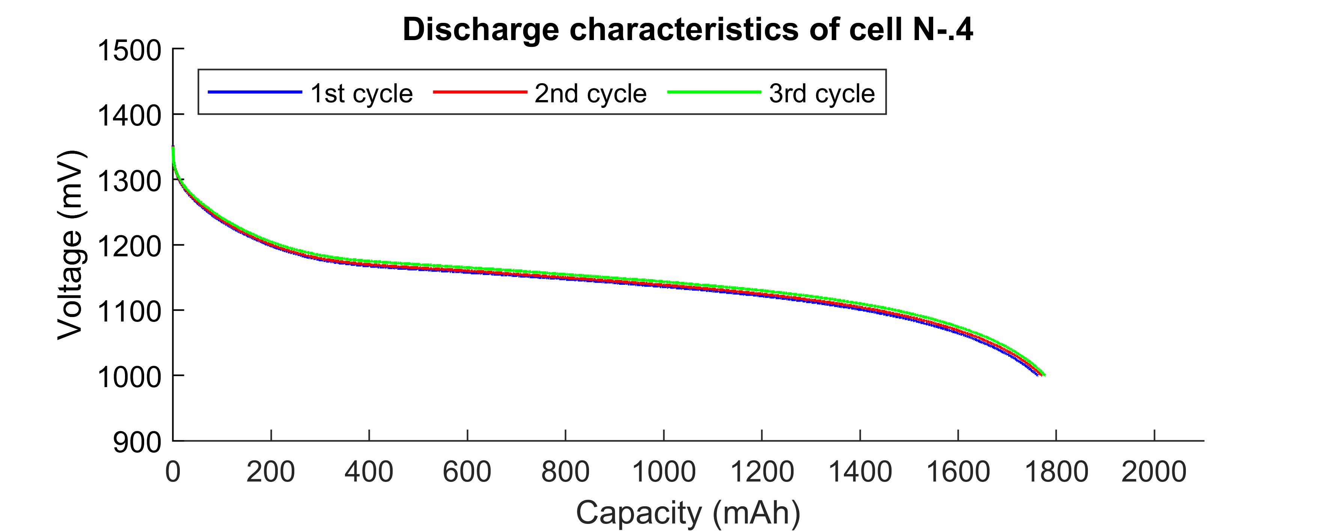

**Figure 7-1 Results of discharging cell #4**

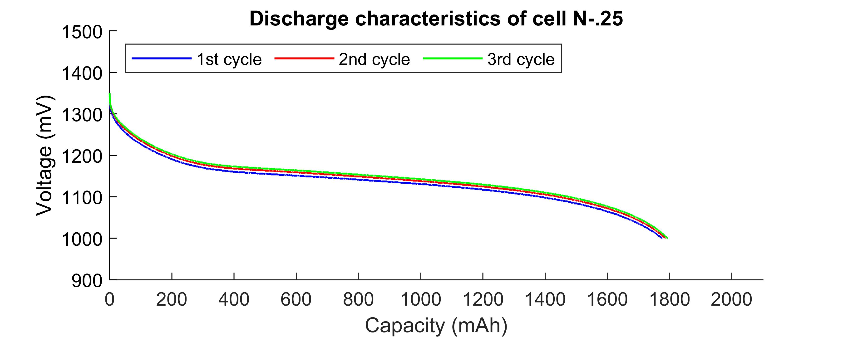

**Figure 7-2 Results of discharging cell #25**

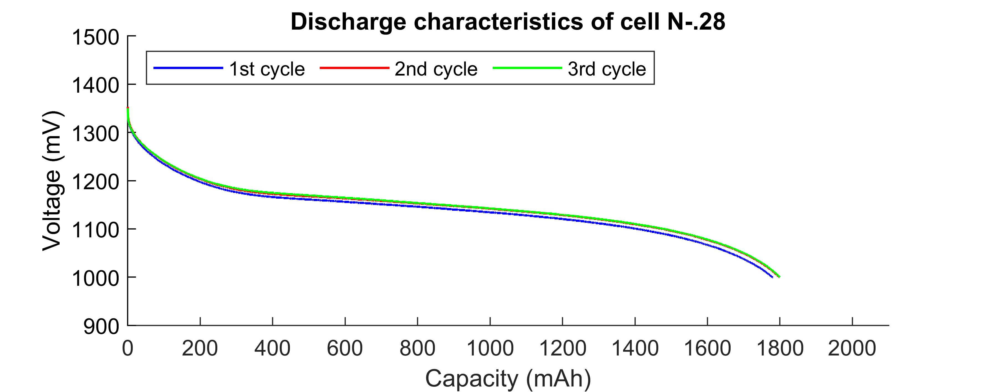

**Figure 7-3 Results of discharging cell #28**

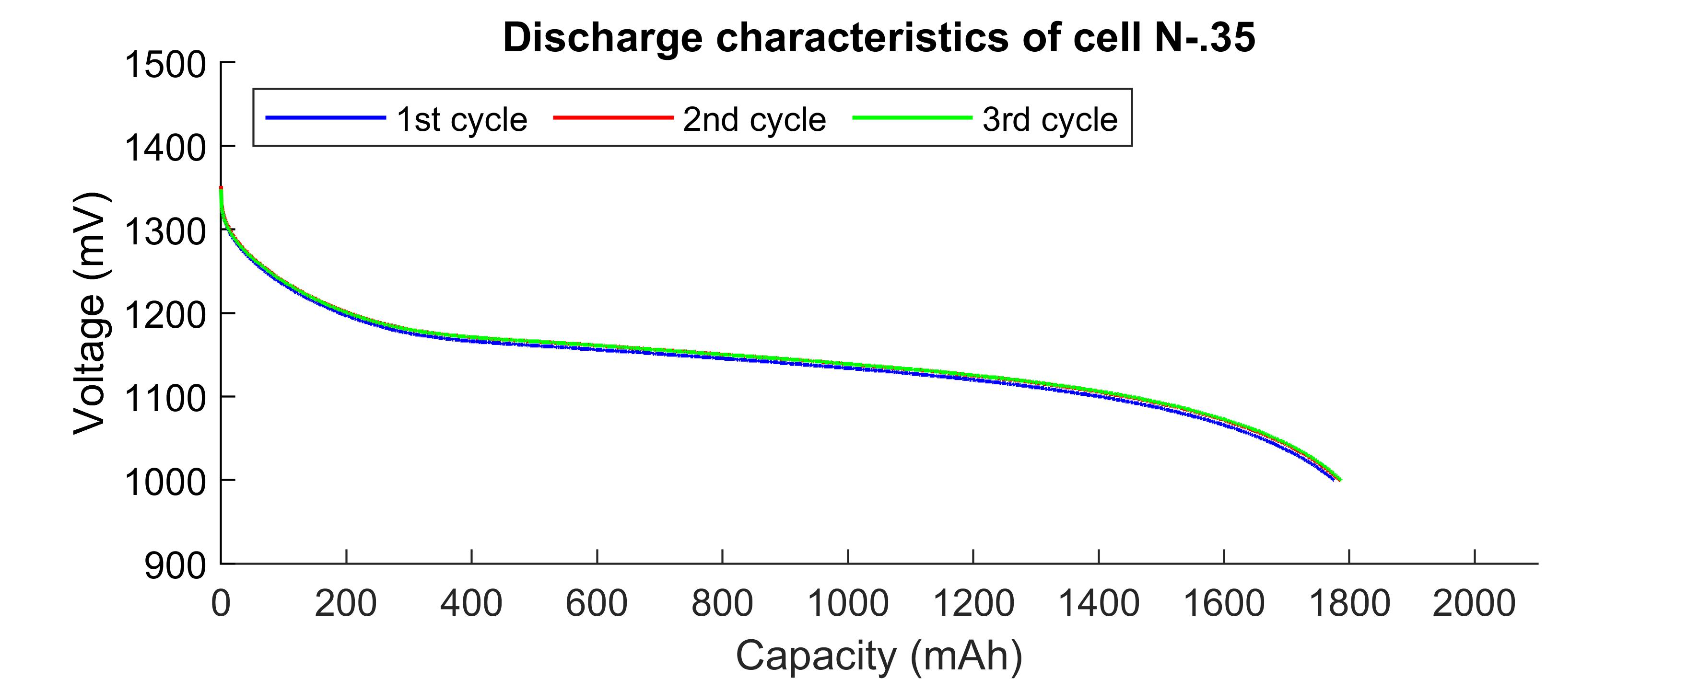

**Figure 7-4 Results of discharging cell #35**

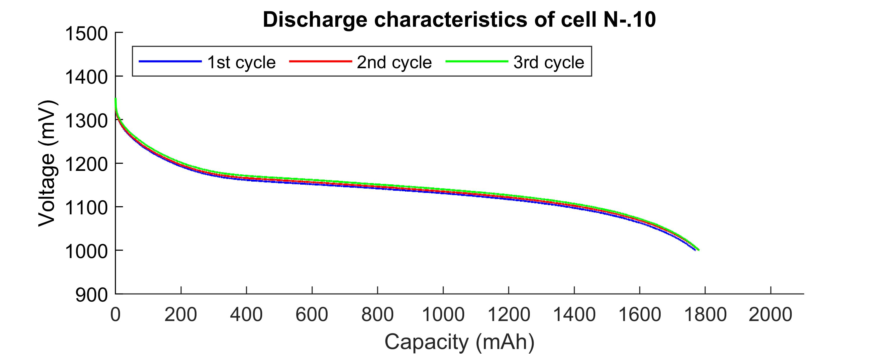

**Figure 7-5 Results of discharging cell #10**

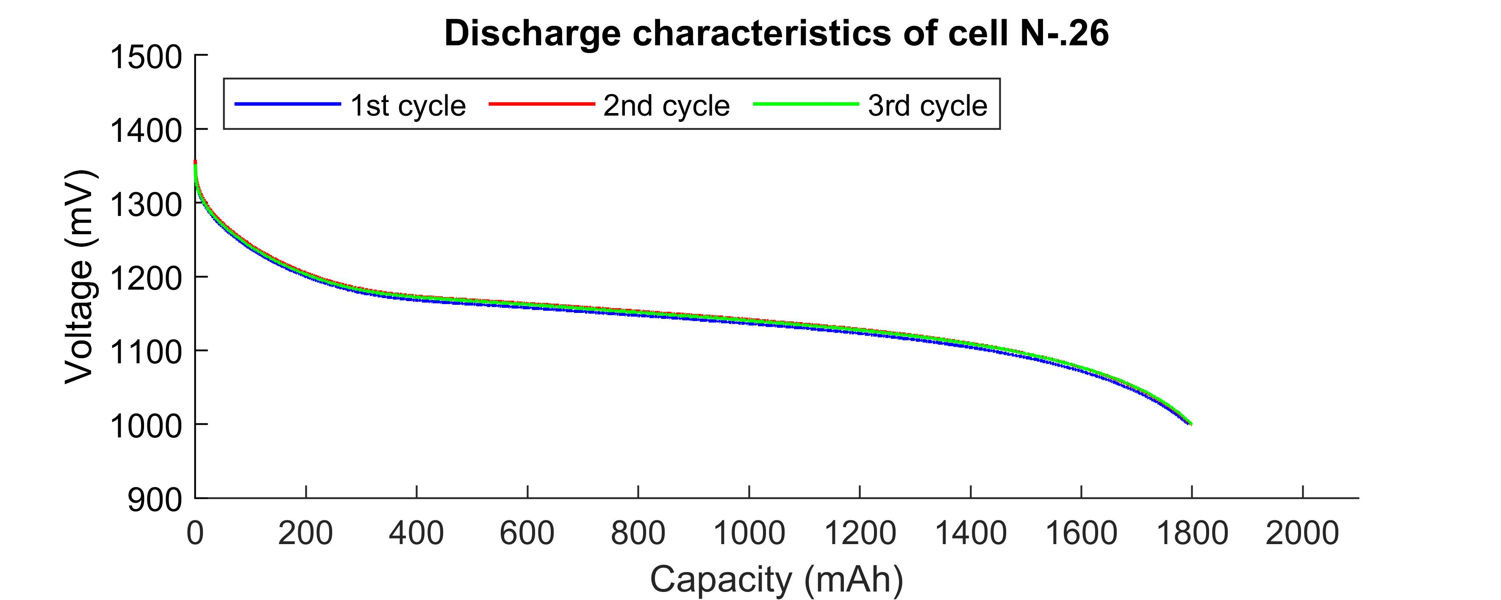

**Figure 7-6 Results of discharging cell #26**

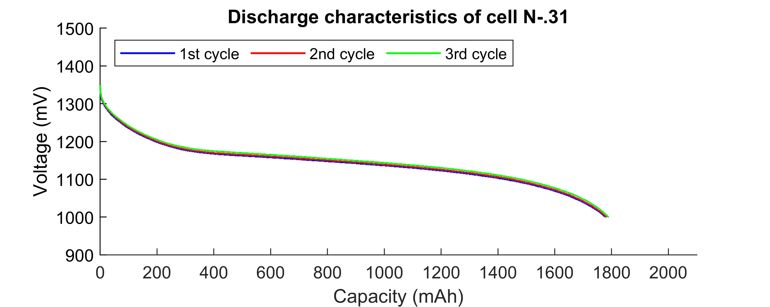

**Figure 7-7 Results of discharging cell #31**

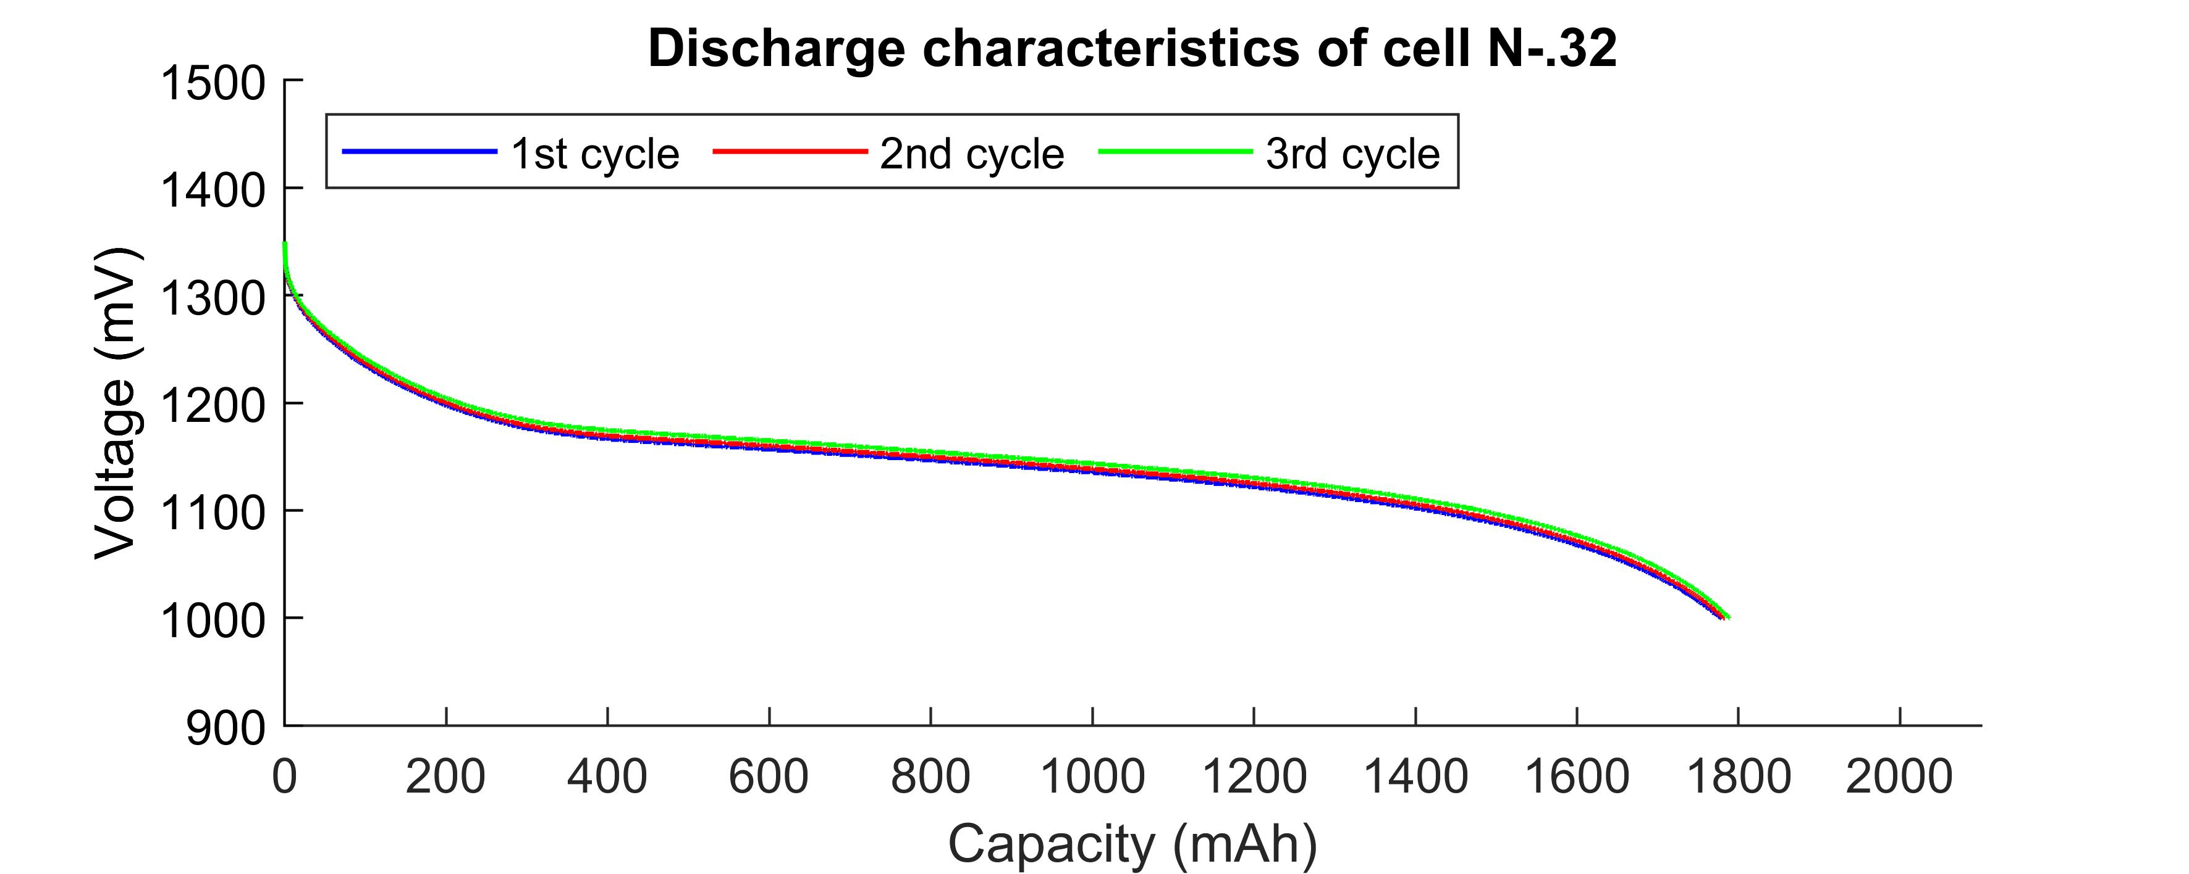

**Figure 7-8 Results of discharging cell #32**

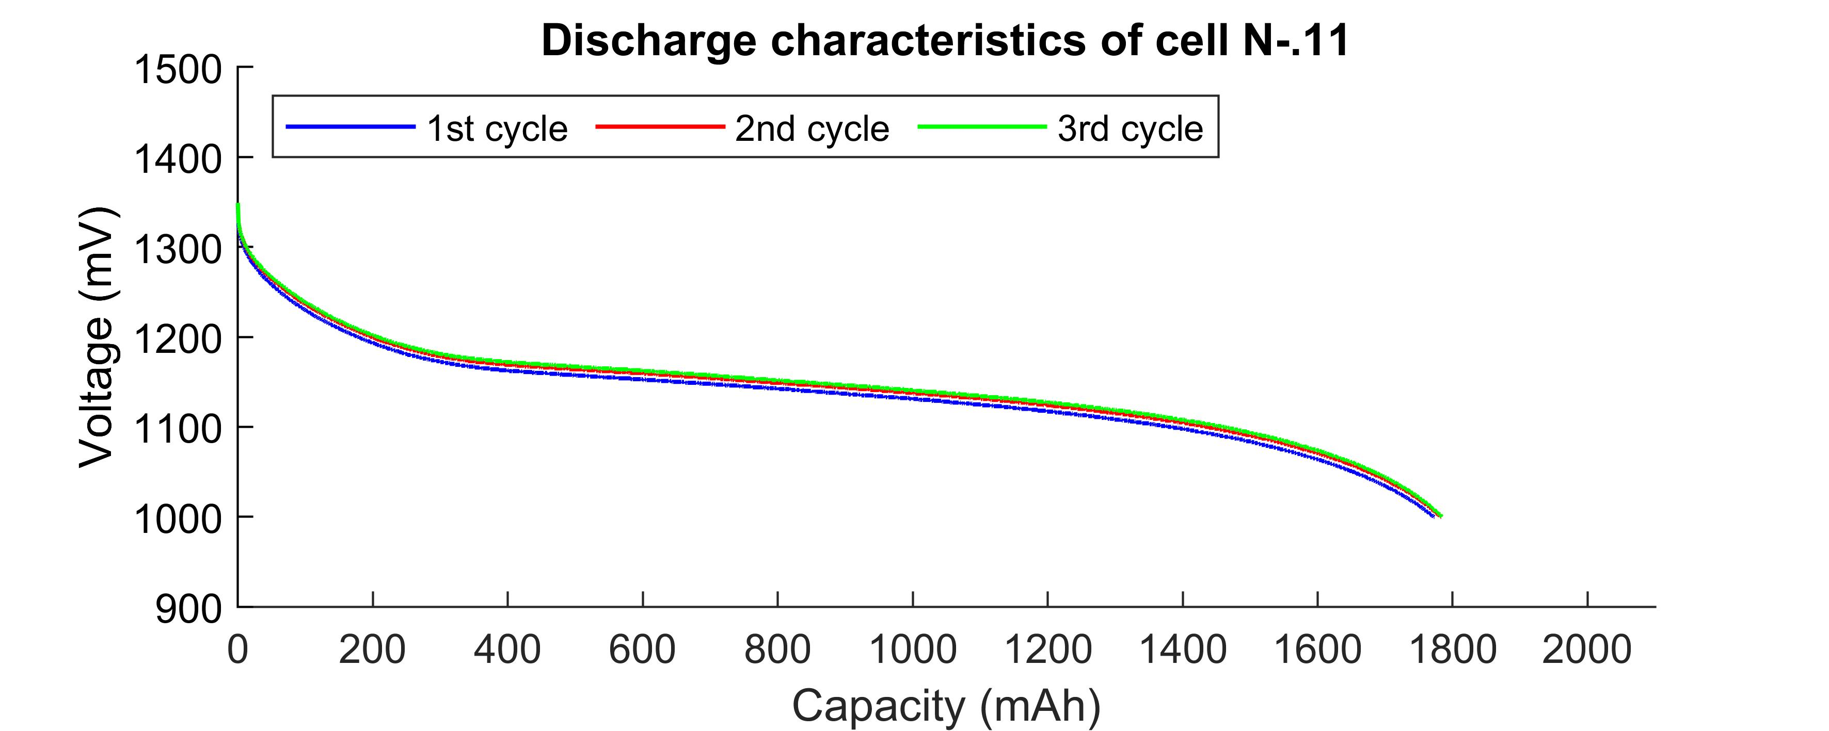

**Figure 7-9 Results of discharging cell #11**

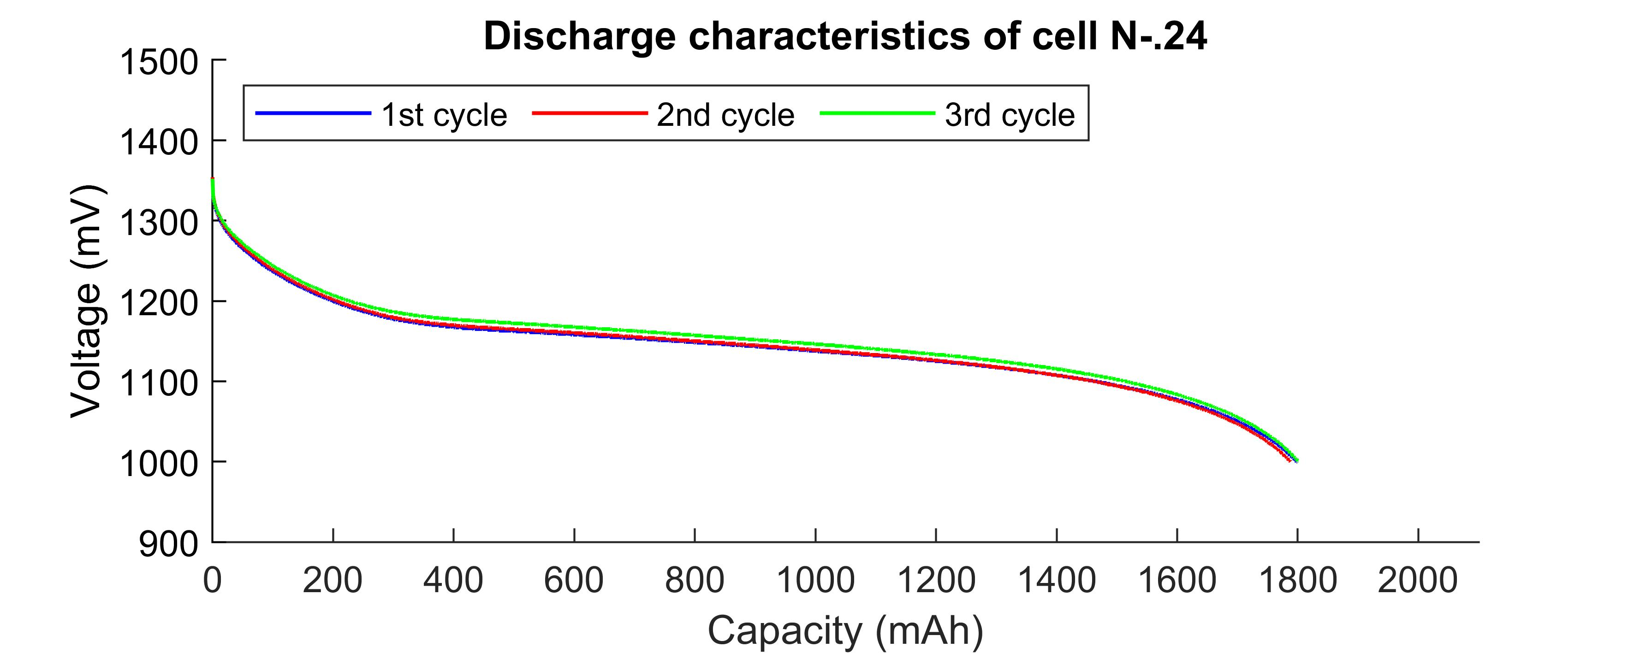

**Figure 7-10 Results of discharging cell #24**

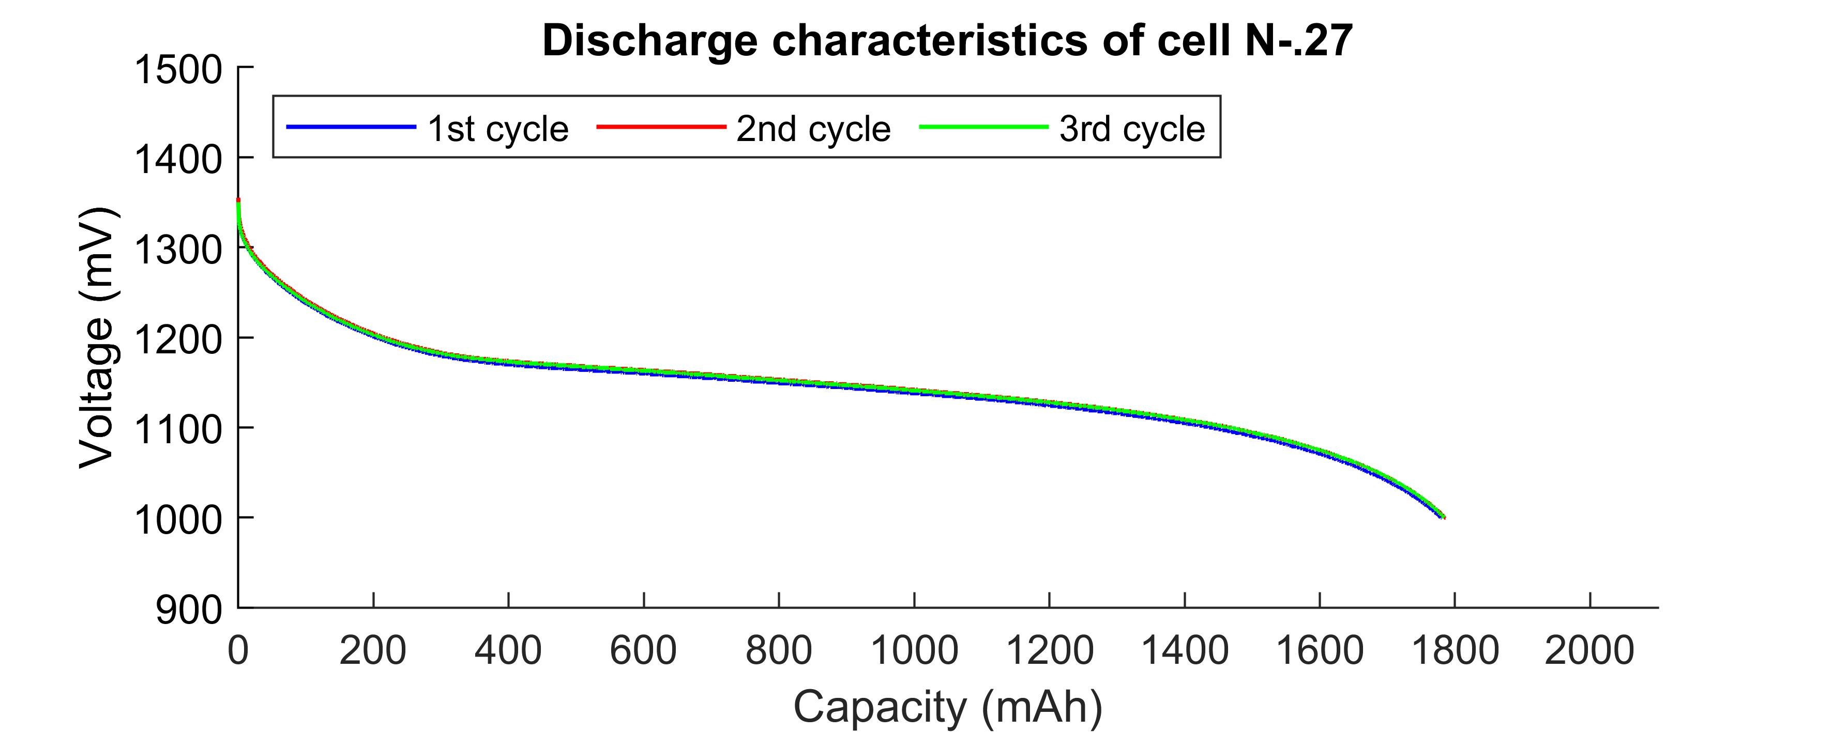

**Figure 7-11 Results of discharging cell #27**

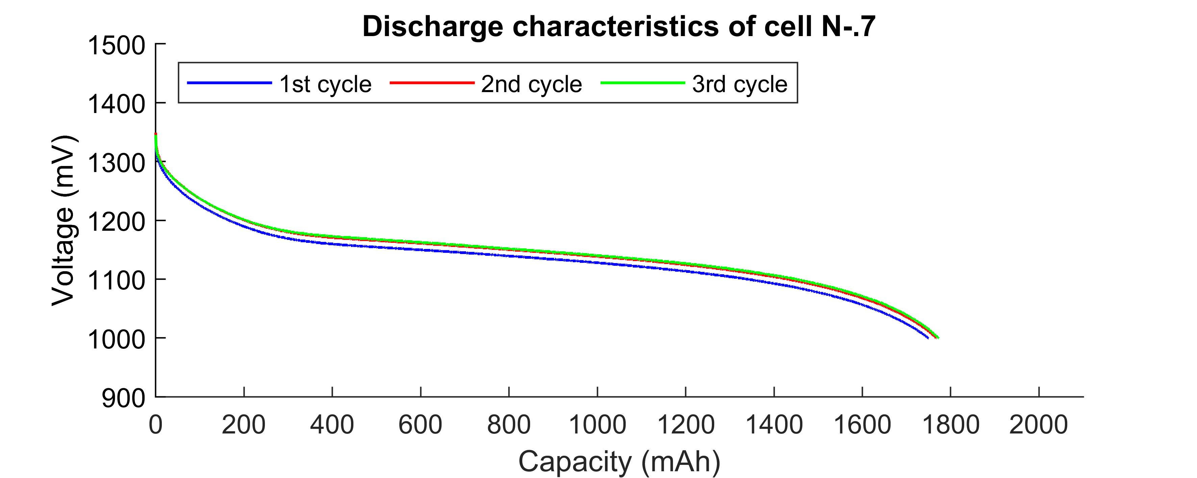

**Figure 7-12 Results of discharging cell #7**

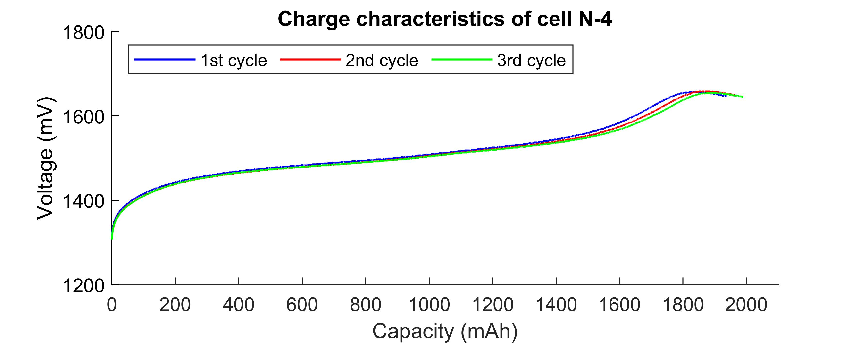

**Figure 7-13 Results of charging cell #4**

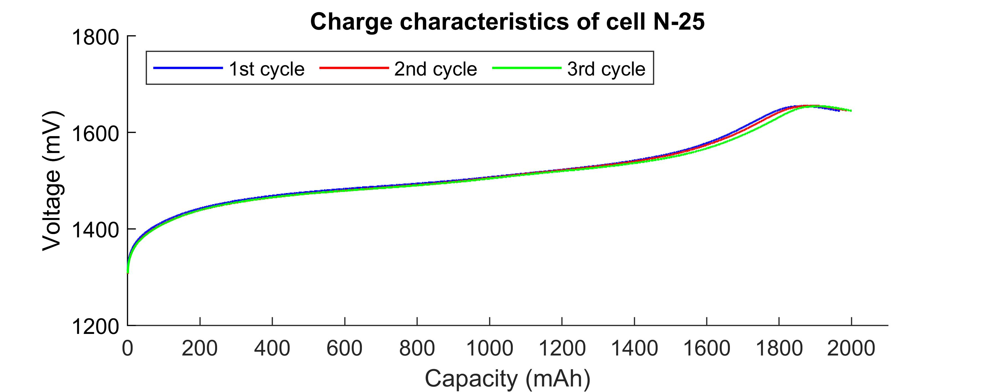

**Figure 7-14 Results of charging cell #25**

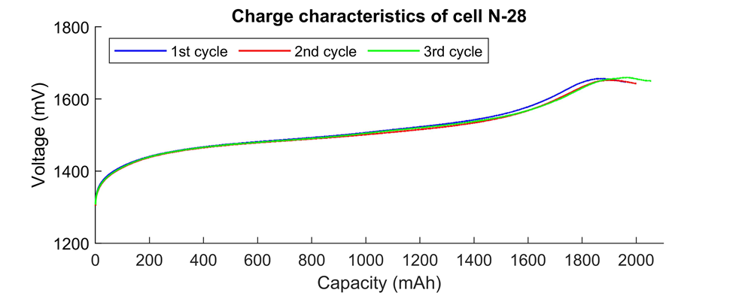

**Figure 7-15 Results of charging cell #28**

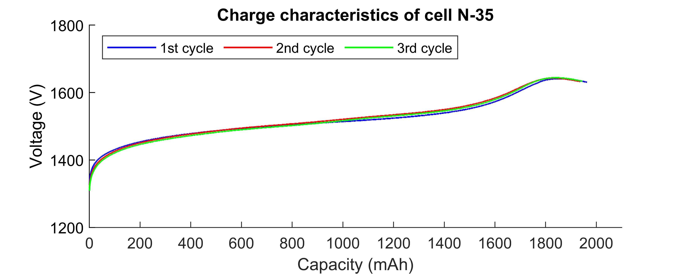

**Figure 7-16 Results of charging cell #35**

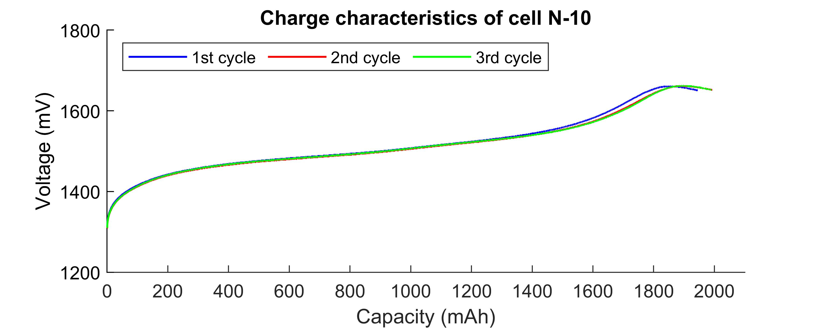

**Figure 7-17 Results of charging cell #10**

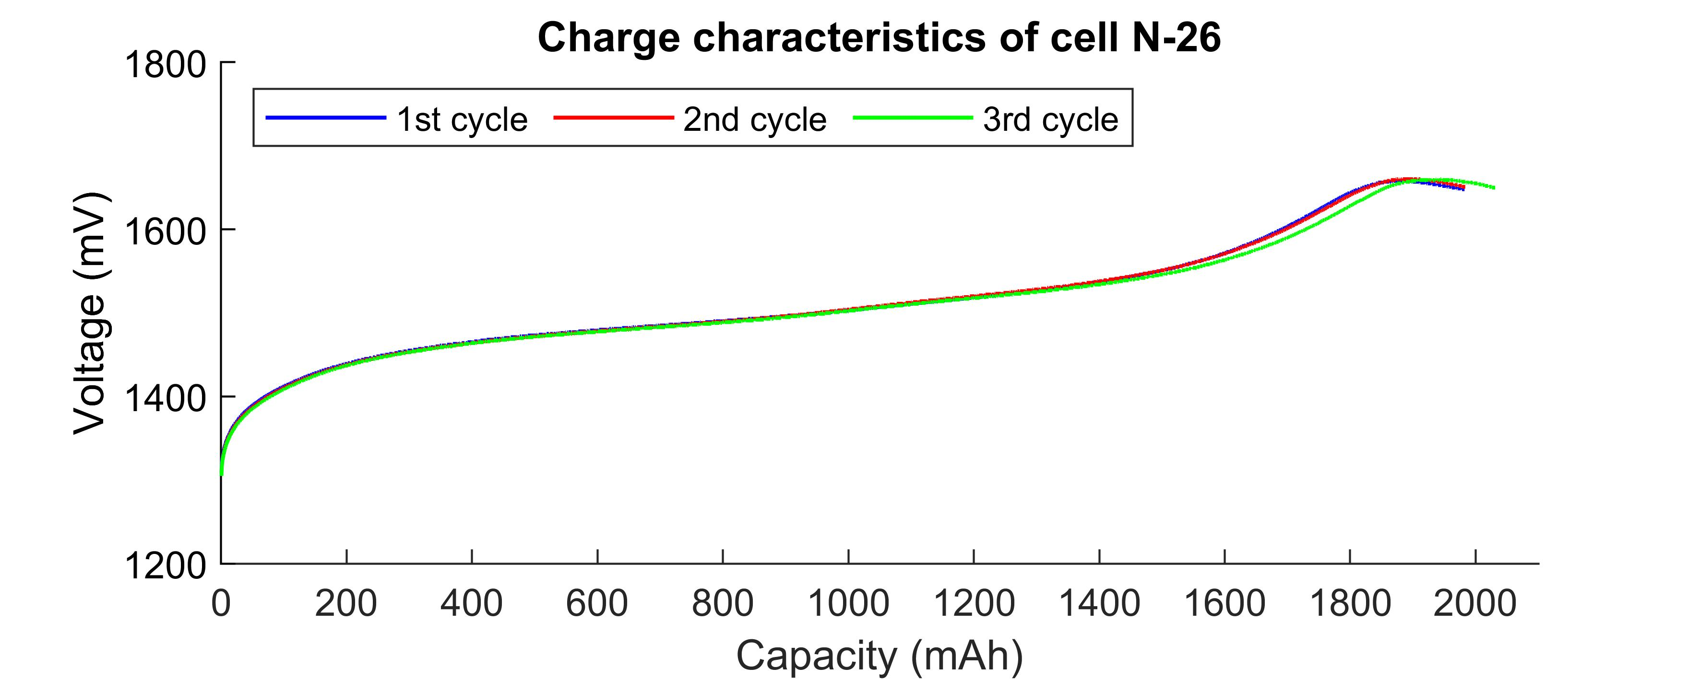

**Figure 7-18 Results of charging cell #26**

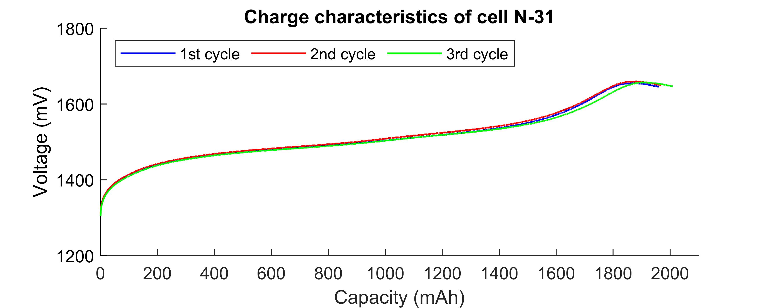

**Figure 7-19 Results of charging cell #31**

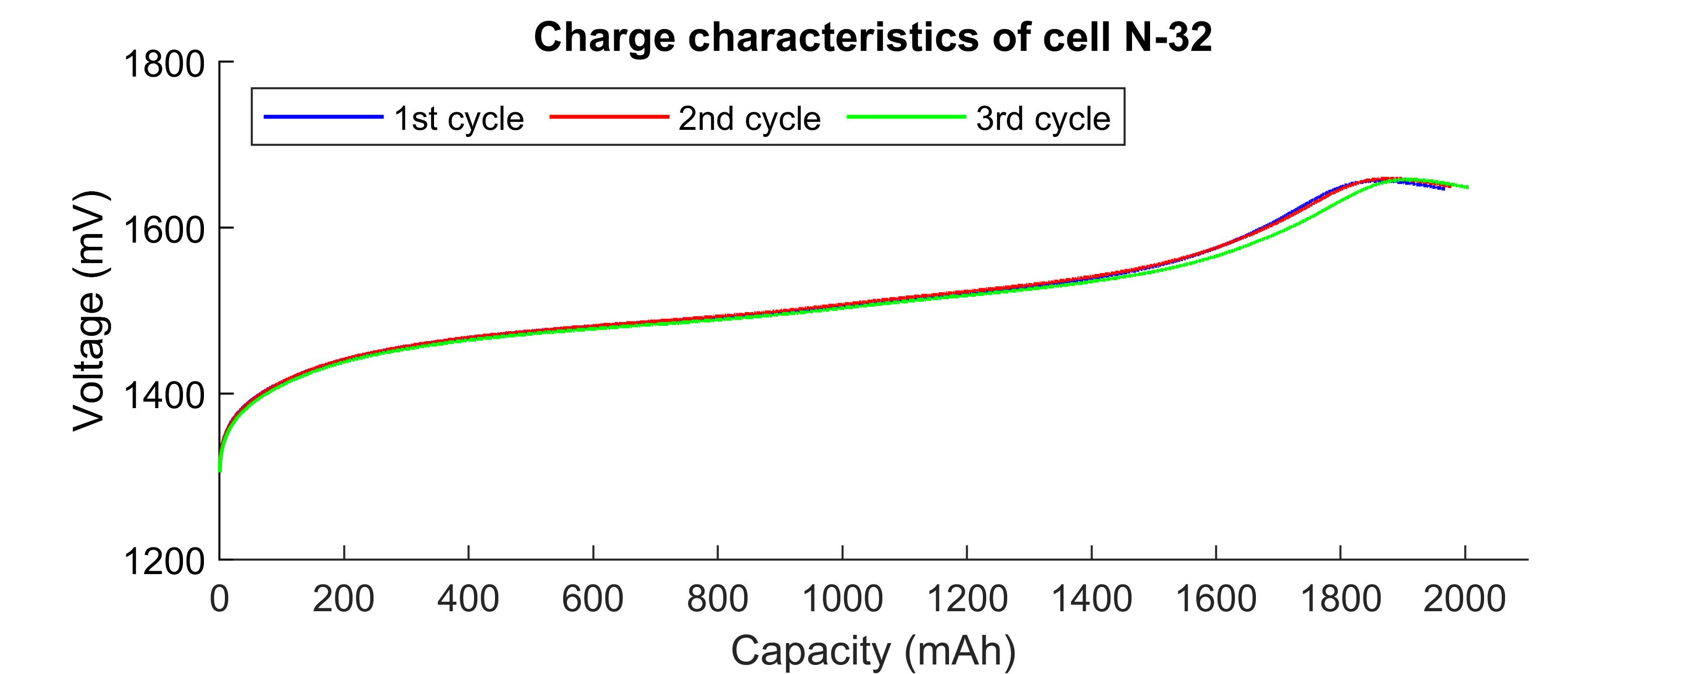

**Figure 7-20 Results of charging cell #32**

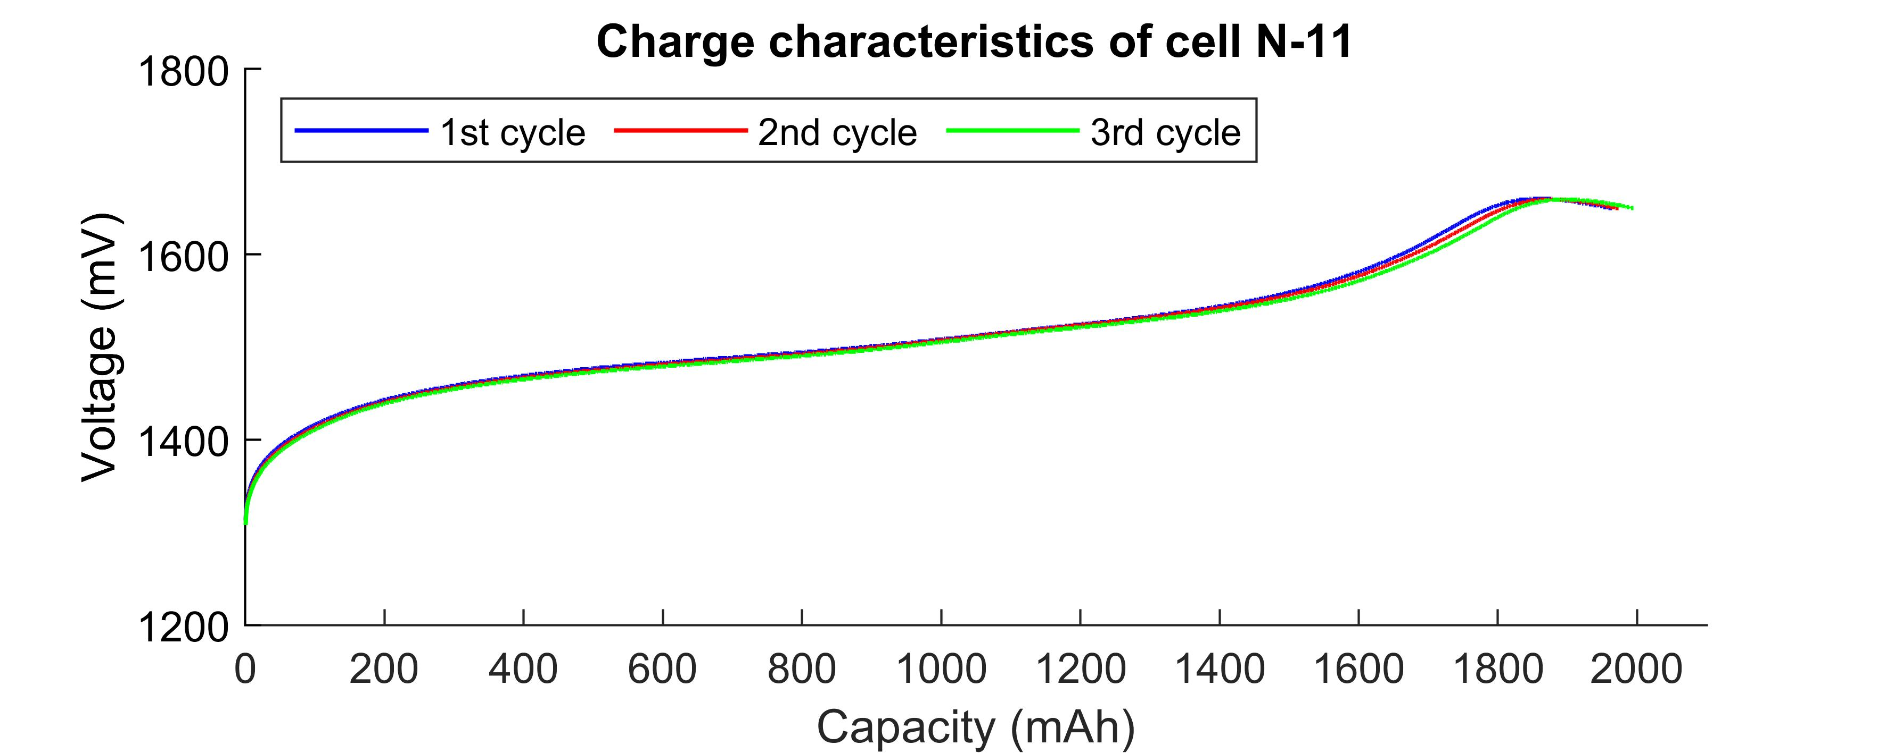

**Figure 7-21 Results of charging cell #11**

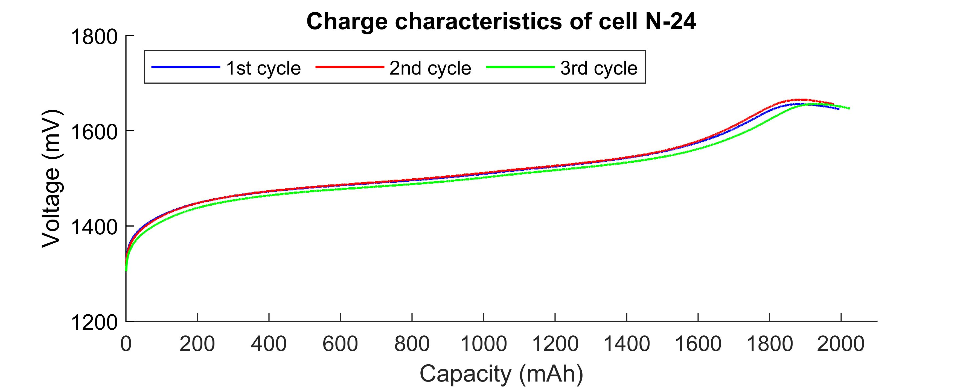

**Figure 7-22 Results of charging cell #24**

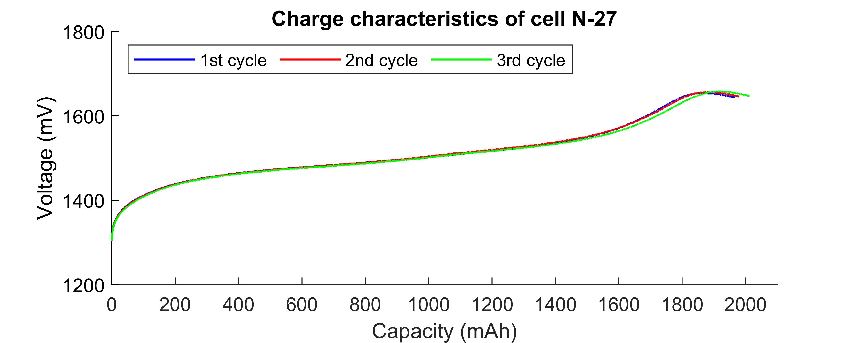

**Figure 7-23 Results of charging cell #27**

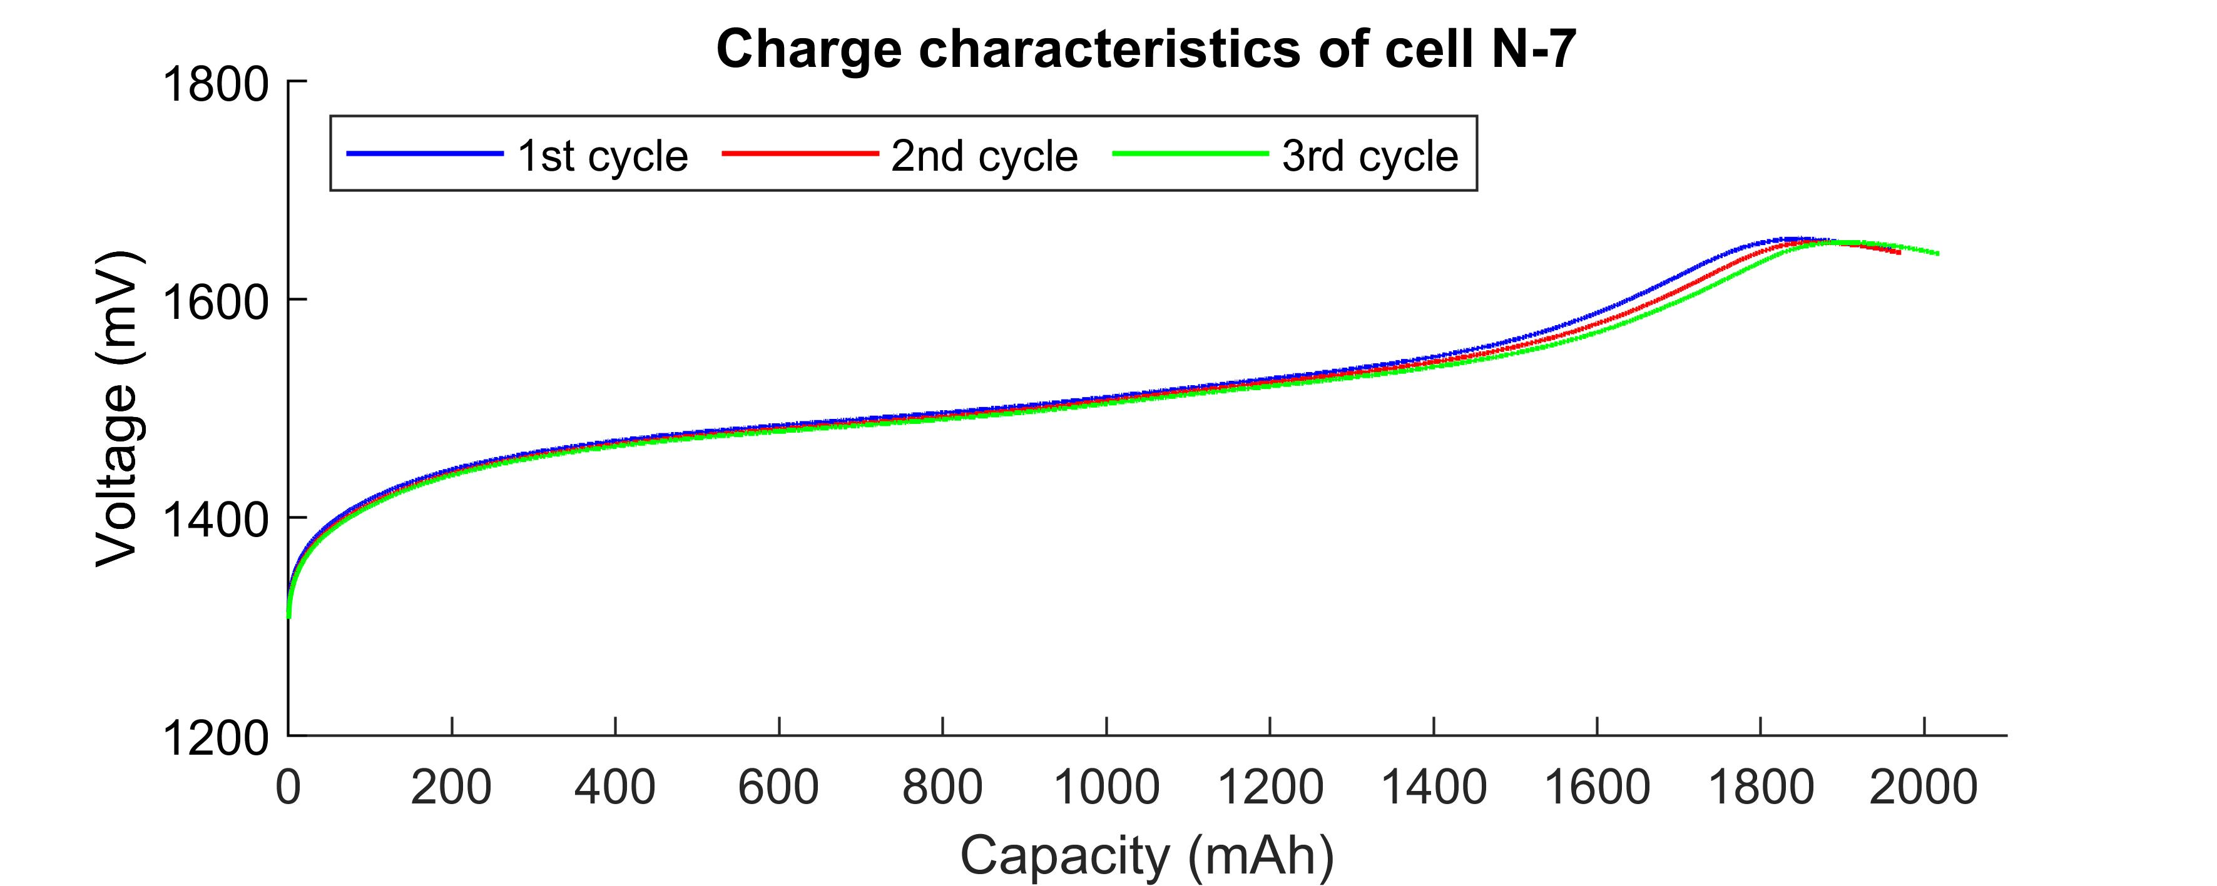

**Figure 7-24 Results of charging cell #7**

The following figures are the results of the cell discharging temperature during the cell discharging process before and after the vacuum test and the battery vibration test (cells). Whereas the red color shows the result before the vacuum test, the blue color shows the result after the vacuum test. The green color result shows the after-vibration test result of cell discharging temperature result of batteries(cells).

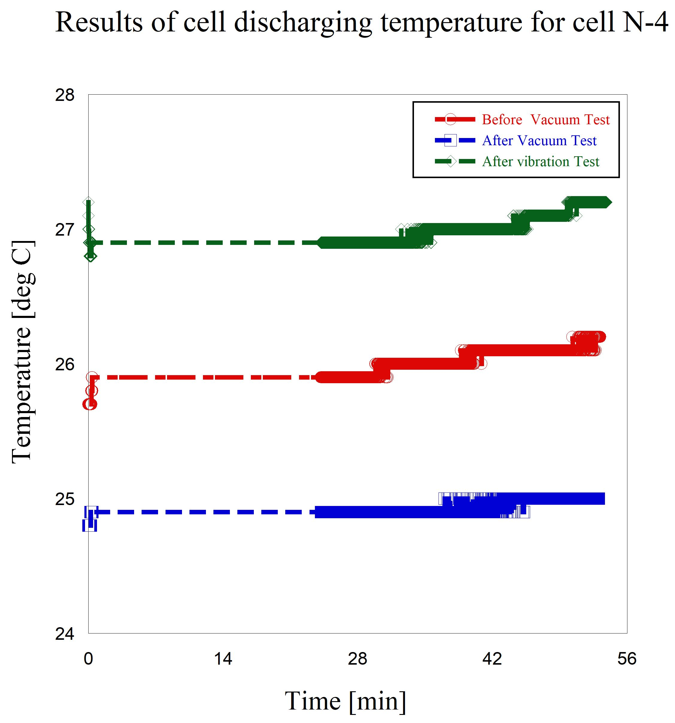

**Figure 7-25 Results of temperature at cell discharging (before & after) the vacuum test and after vibration test, cell N #4**

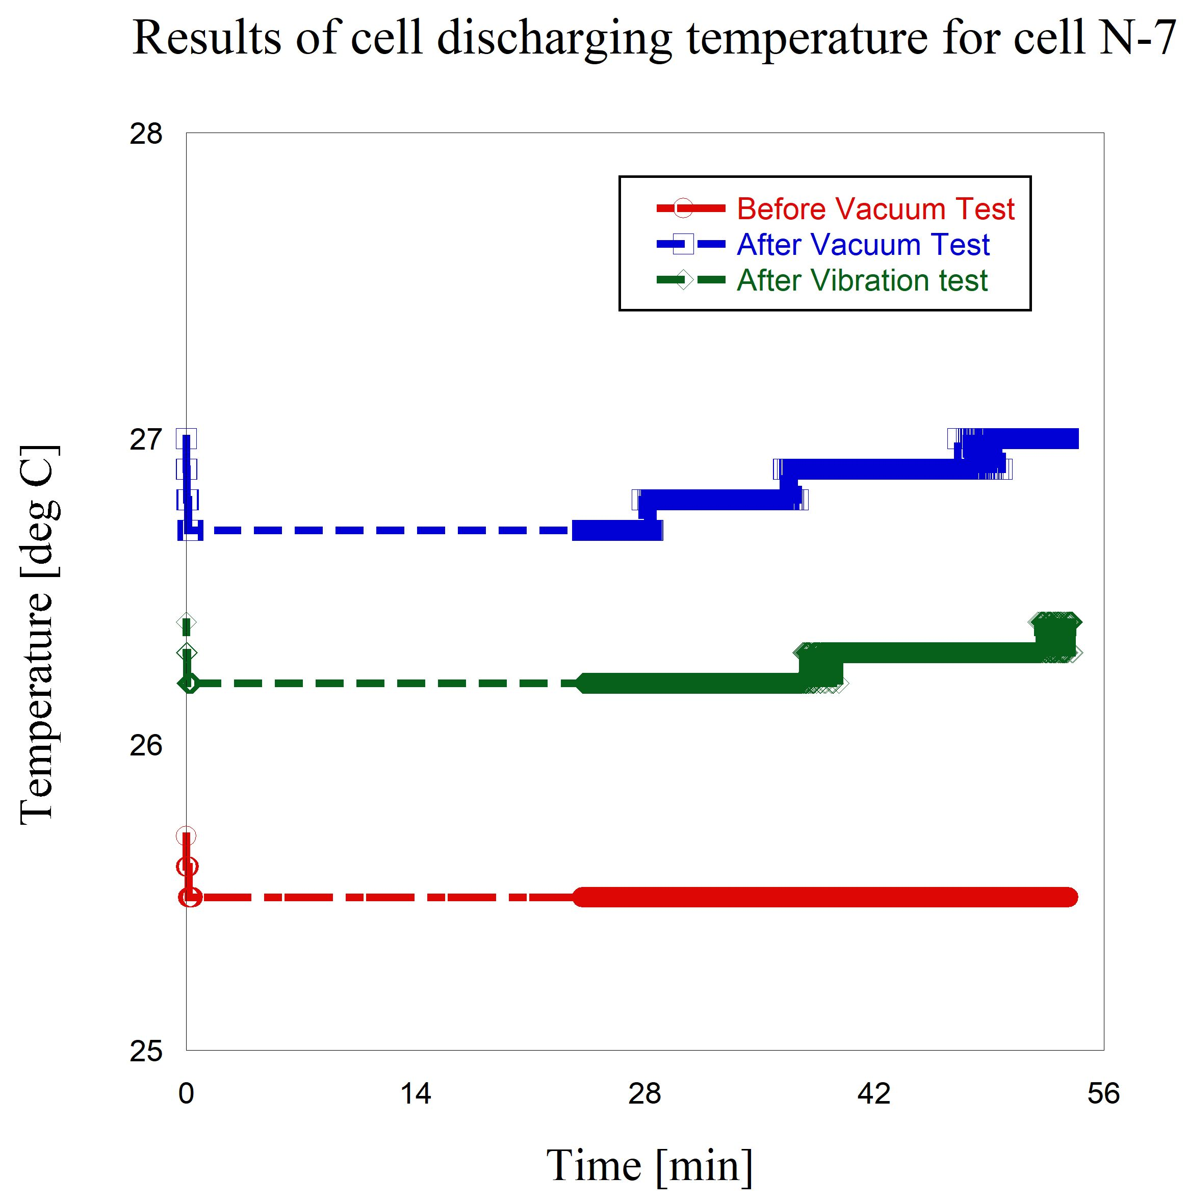

**Figure 7-26 Results of temperature at cell discharging (before & after) the vacuum test and after vibration test, cell N #7**

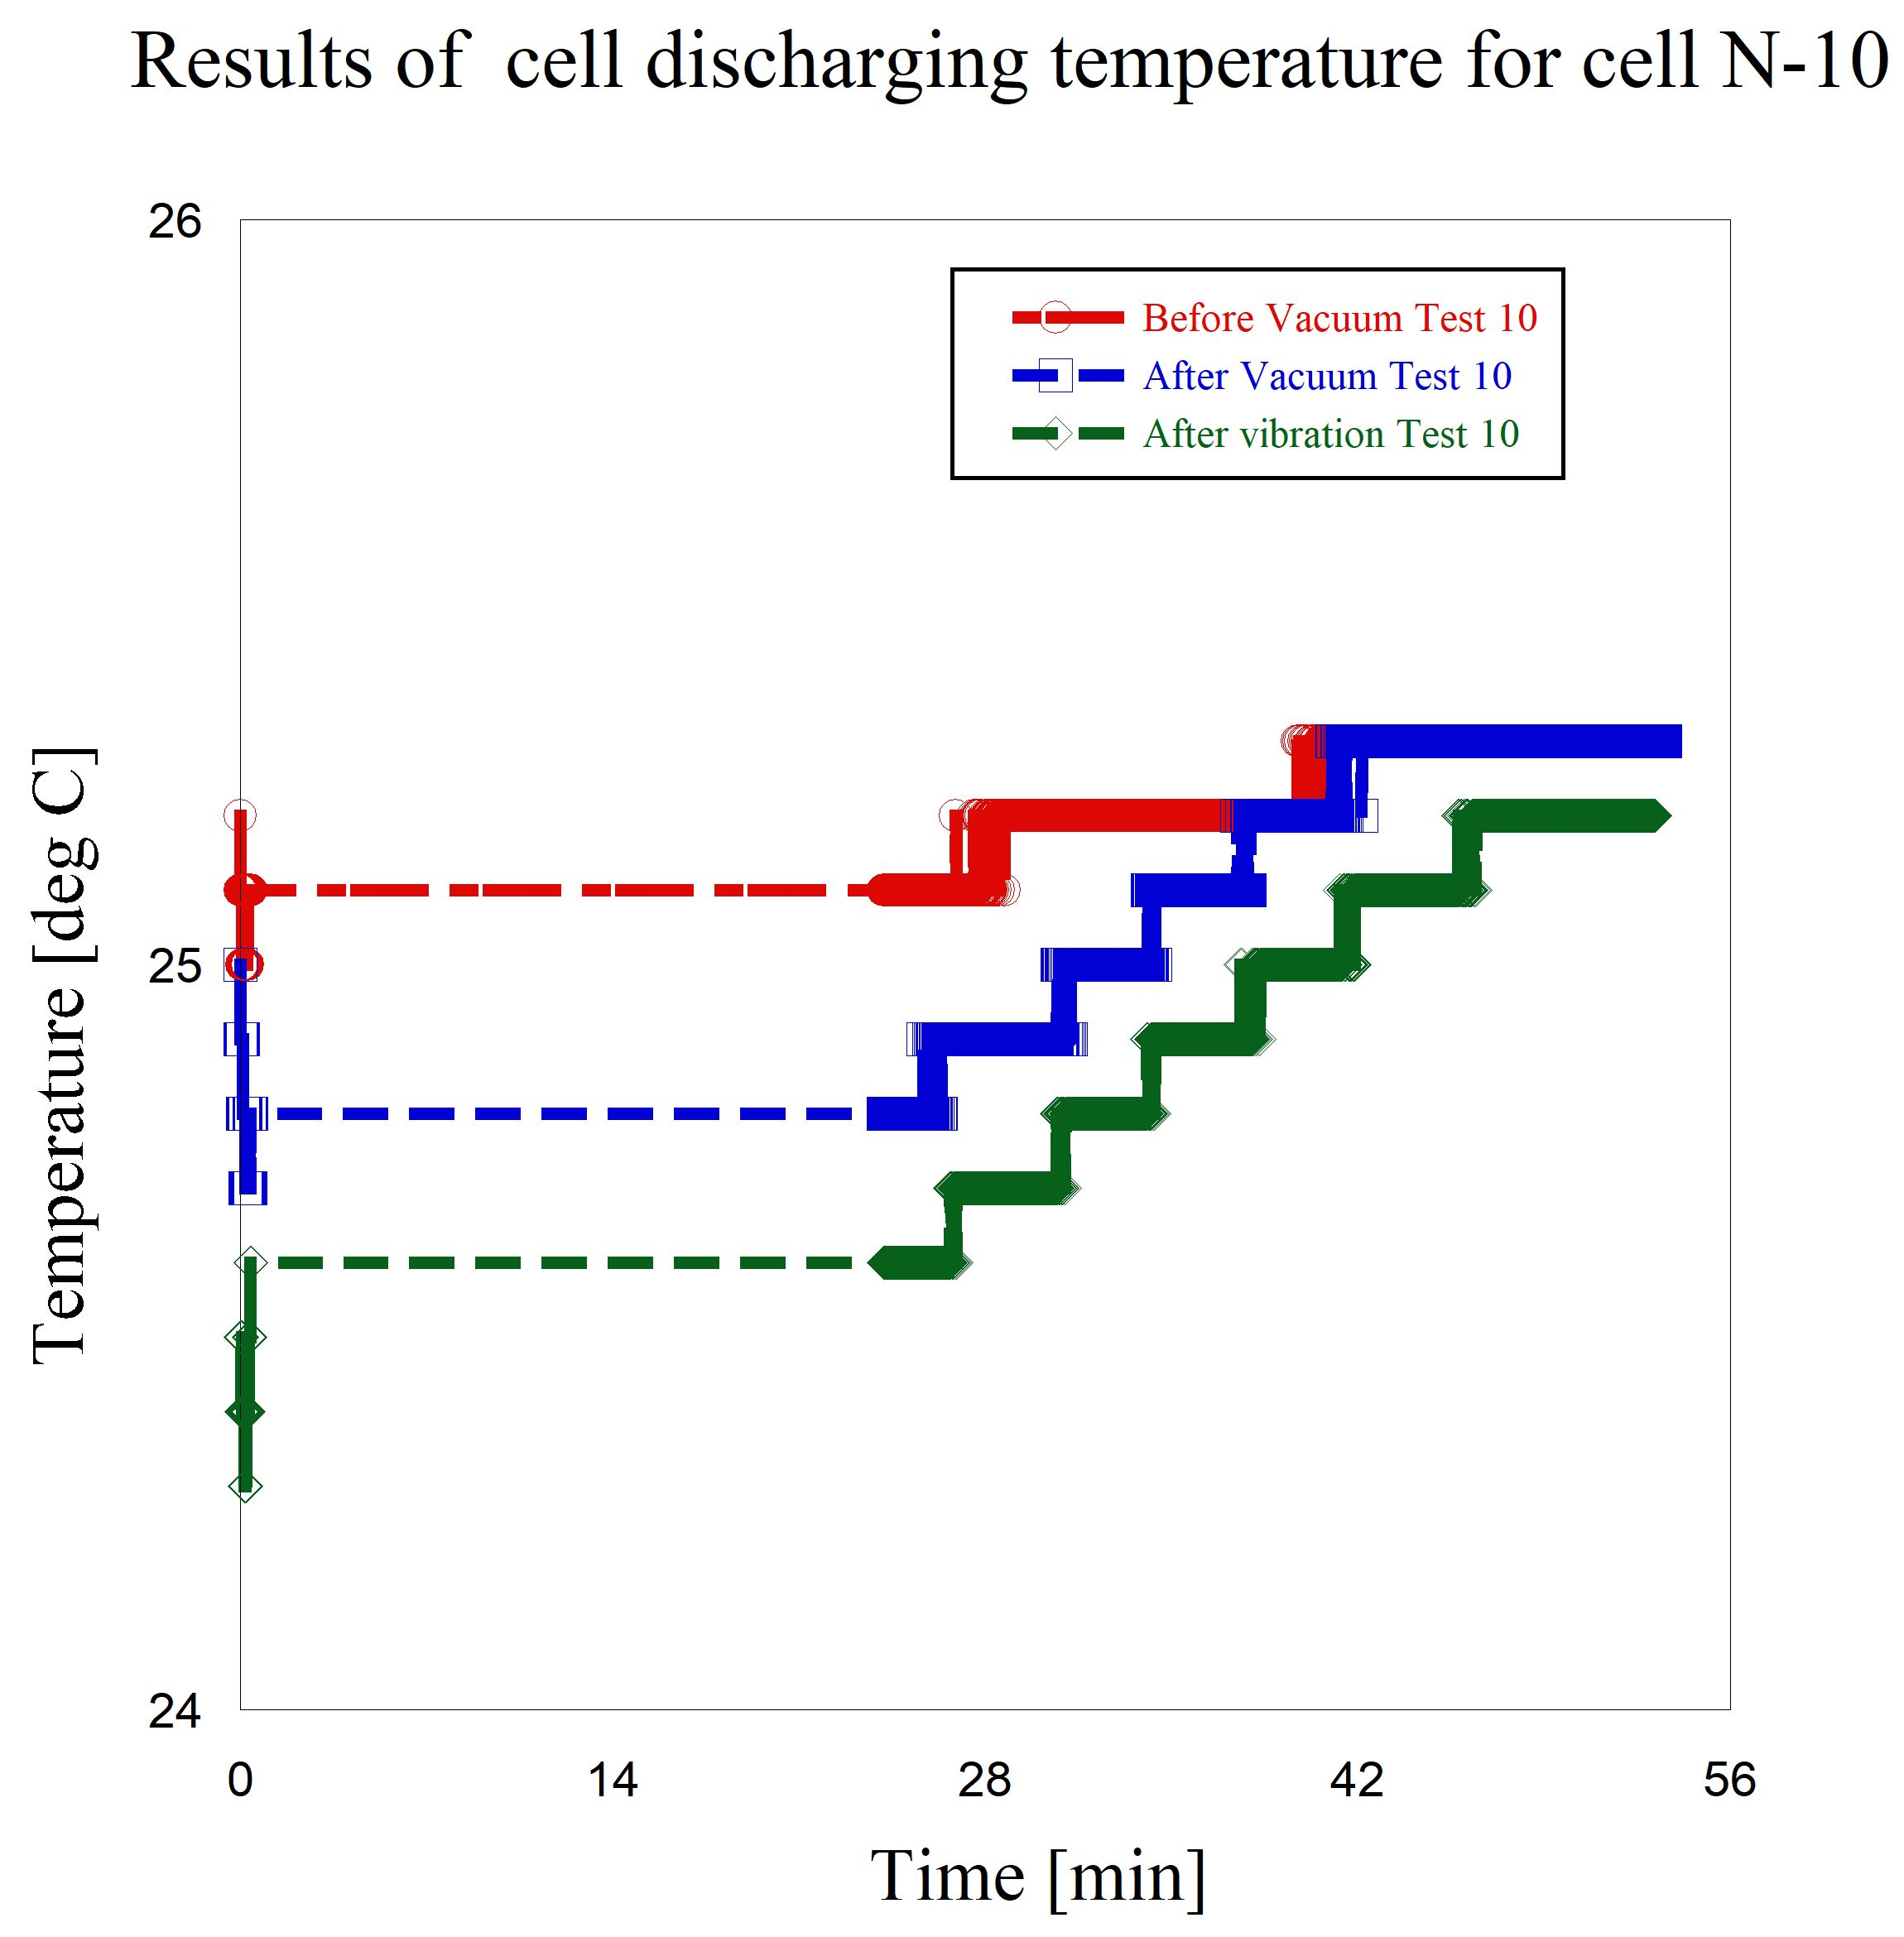

**Figure 7-27 Results of temperature at cell discharging (before & after) the vacuum test and after vibration test, cell N #10**

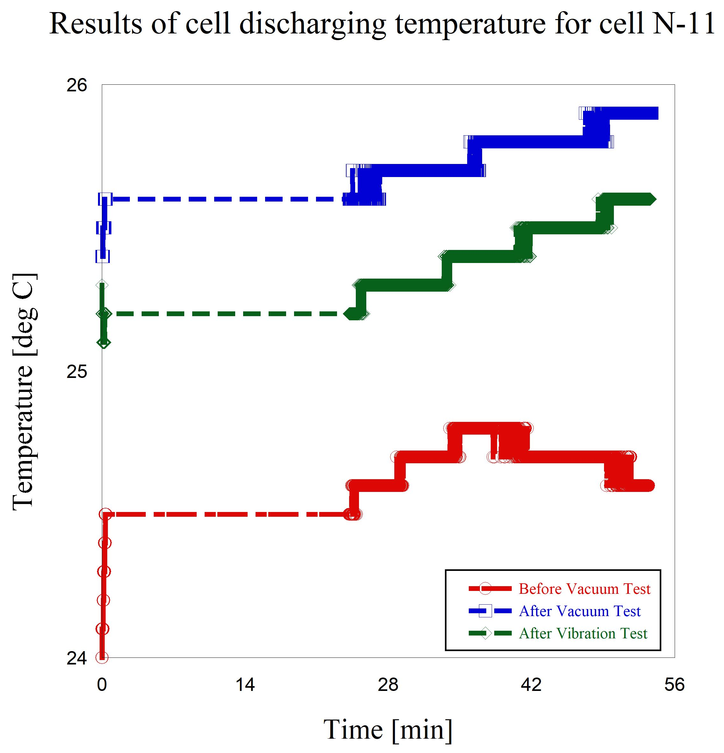

**Figure 7-28 Results of temperature at cell discharging (before & after) the vacuum test and after vibration test, cell N #11**

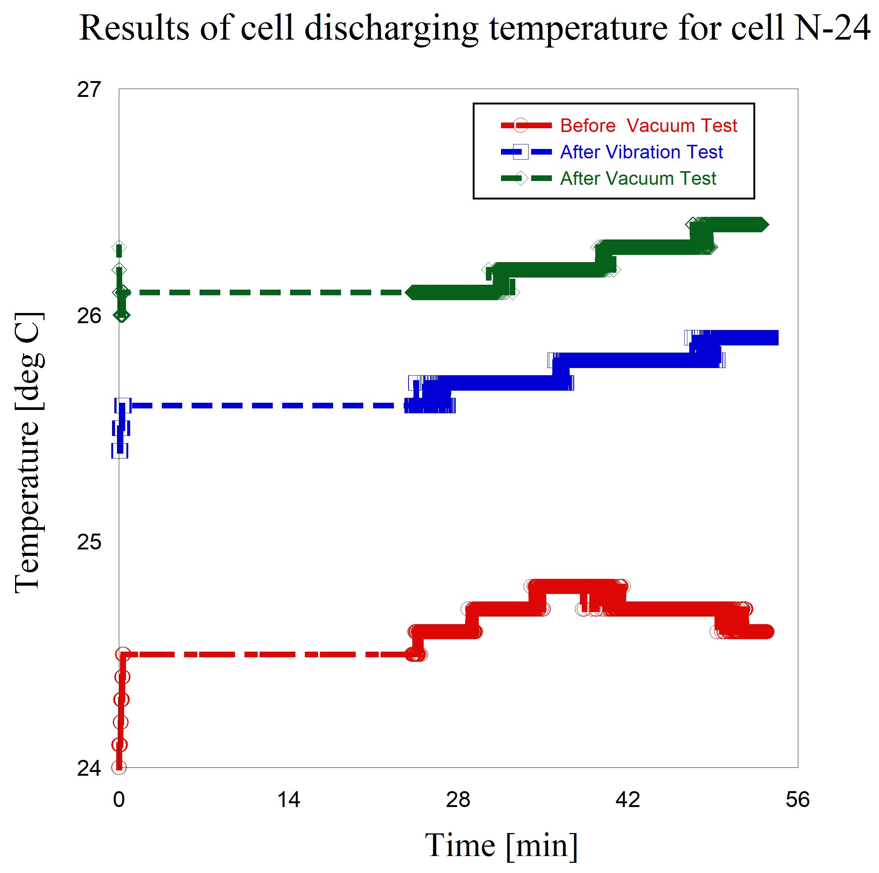

**Figure 7-29 Results of temperature at cell discharging (before & after) the vacuum test and after vibration test, cell N #24**

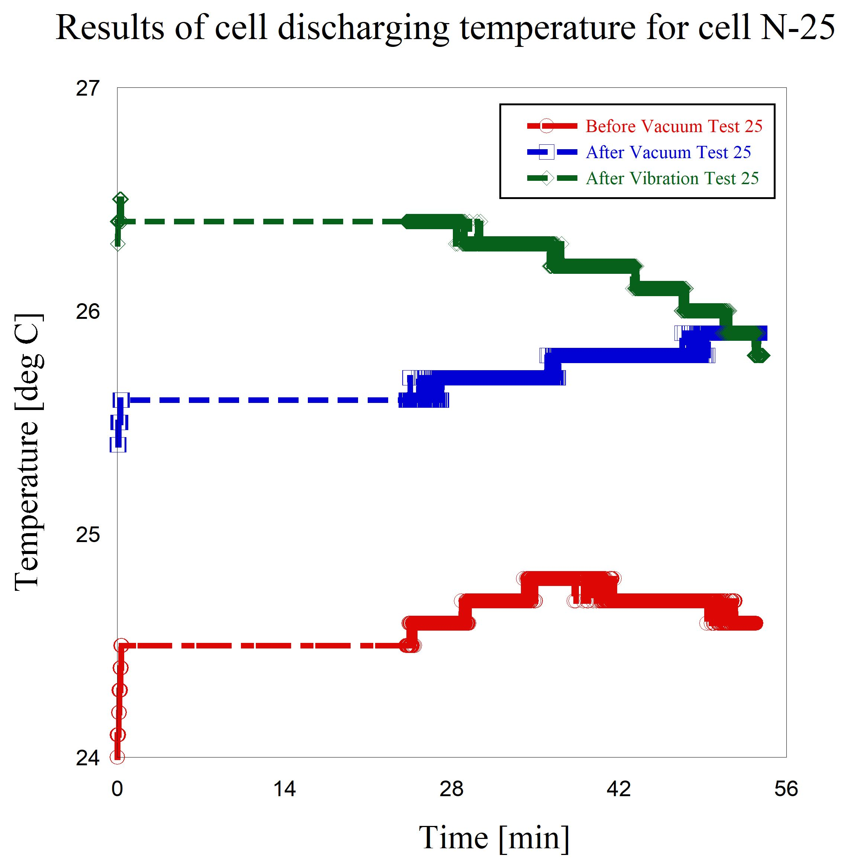

**Figure 7-30 Results of temperature at cell discharging (before & after) the vacuum test and after vibration test, cell N #25**

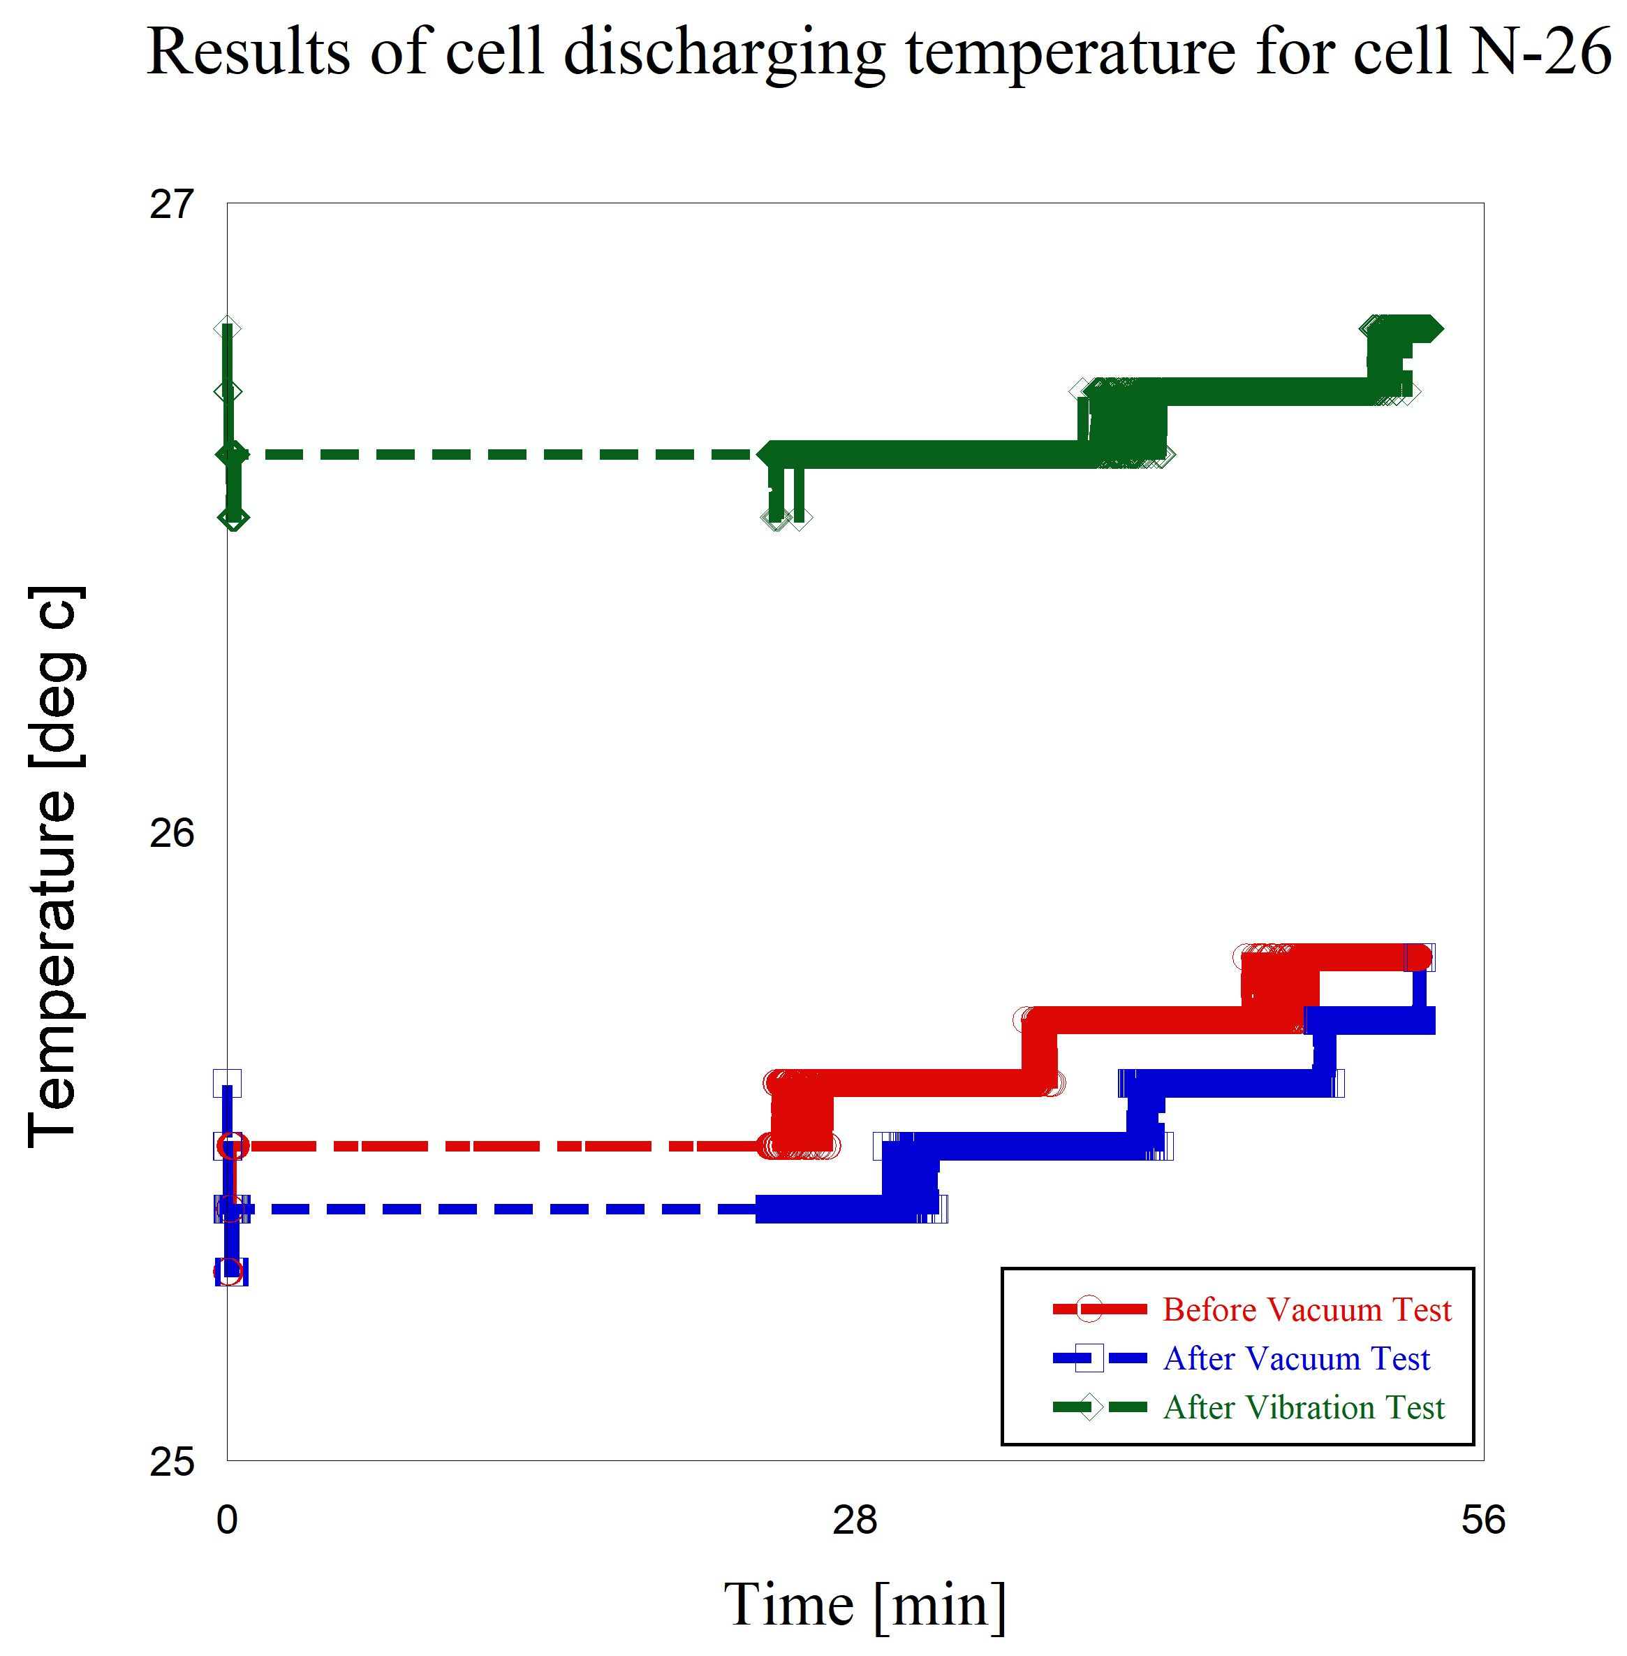

**Figure 7-31 Results of temperature at cell discharging (before & after) the vacuum test and after vibration test, cell N #26**

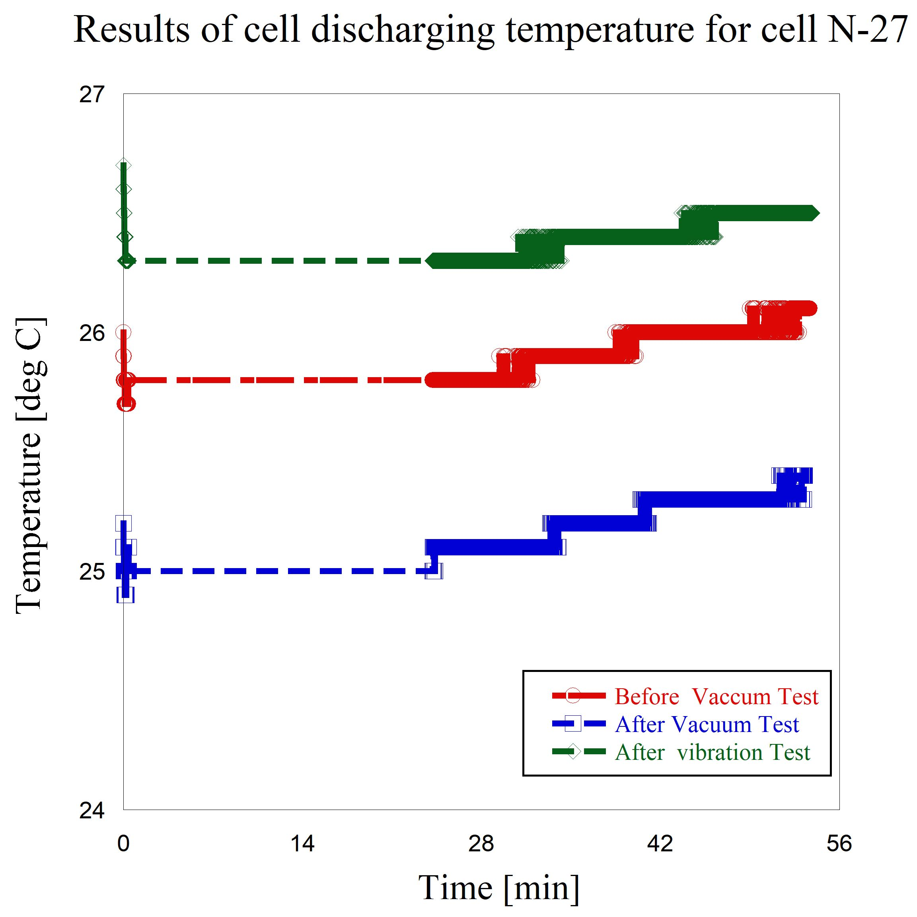

**Figure 7-32 Results of temperature at cell discharging (before & after) the vacuum test and after vibration test, cell N #27**

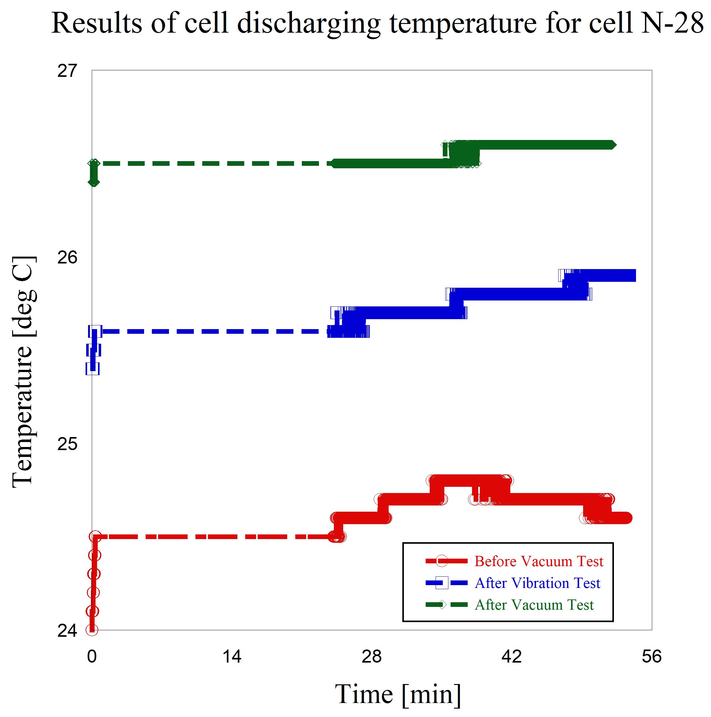

**Figure 7-33 Results of temperature at cell discharging (before & after) the vacuum test and after vibration test, cell N #28**

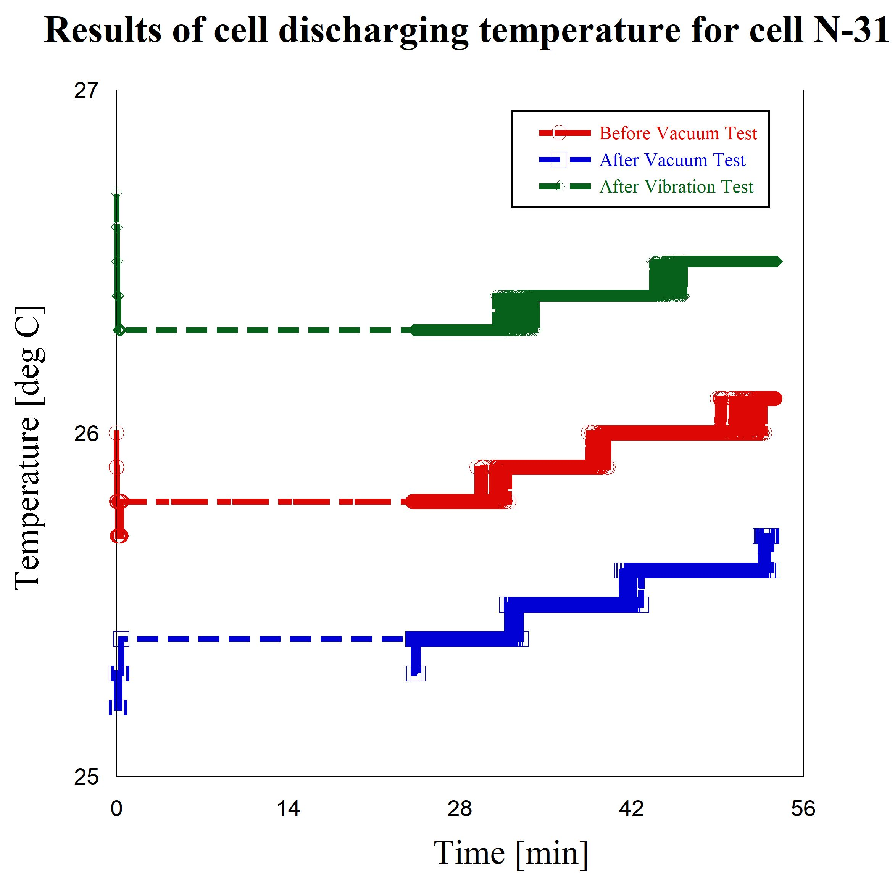

**Figure 7-34 Results of temperature at cell discharging (before & after) the vacuum test and after vibration test, cell N #31**

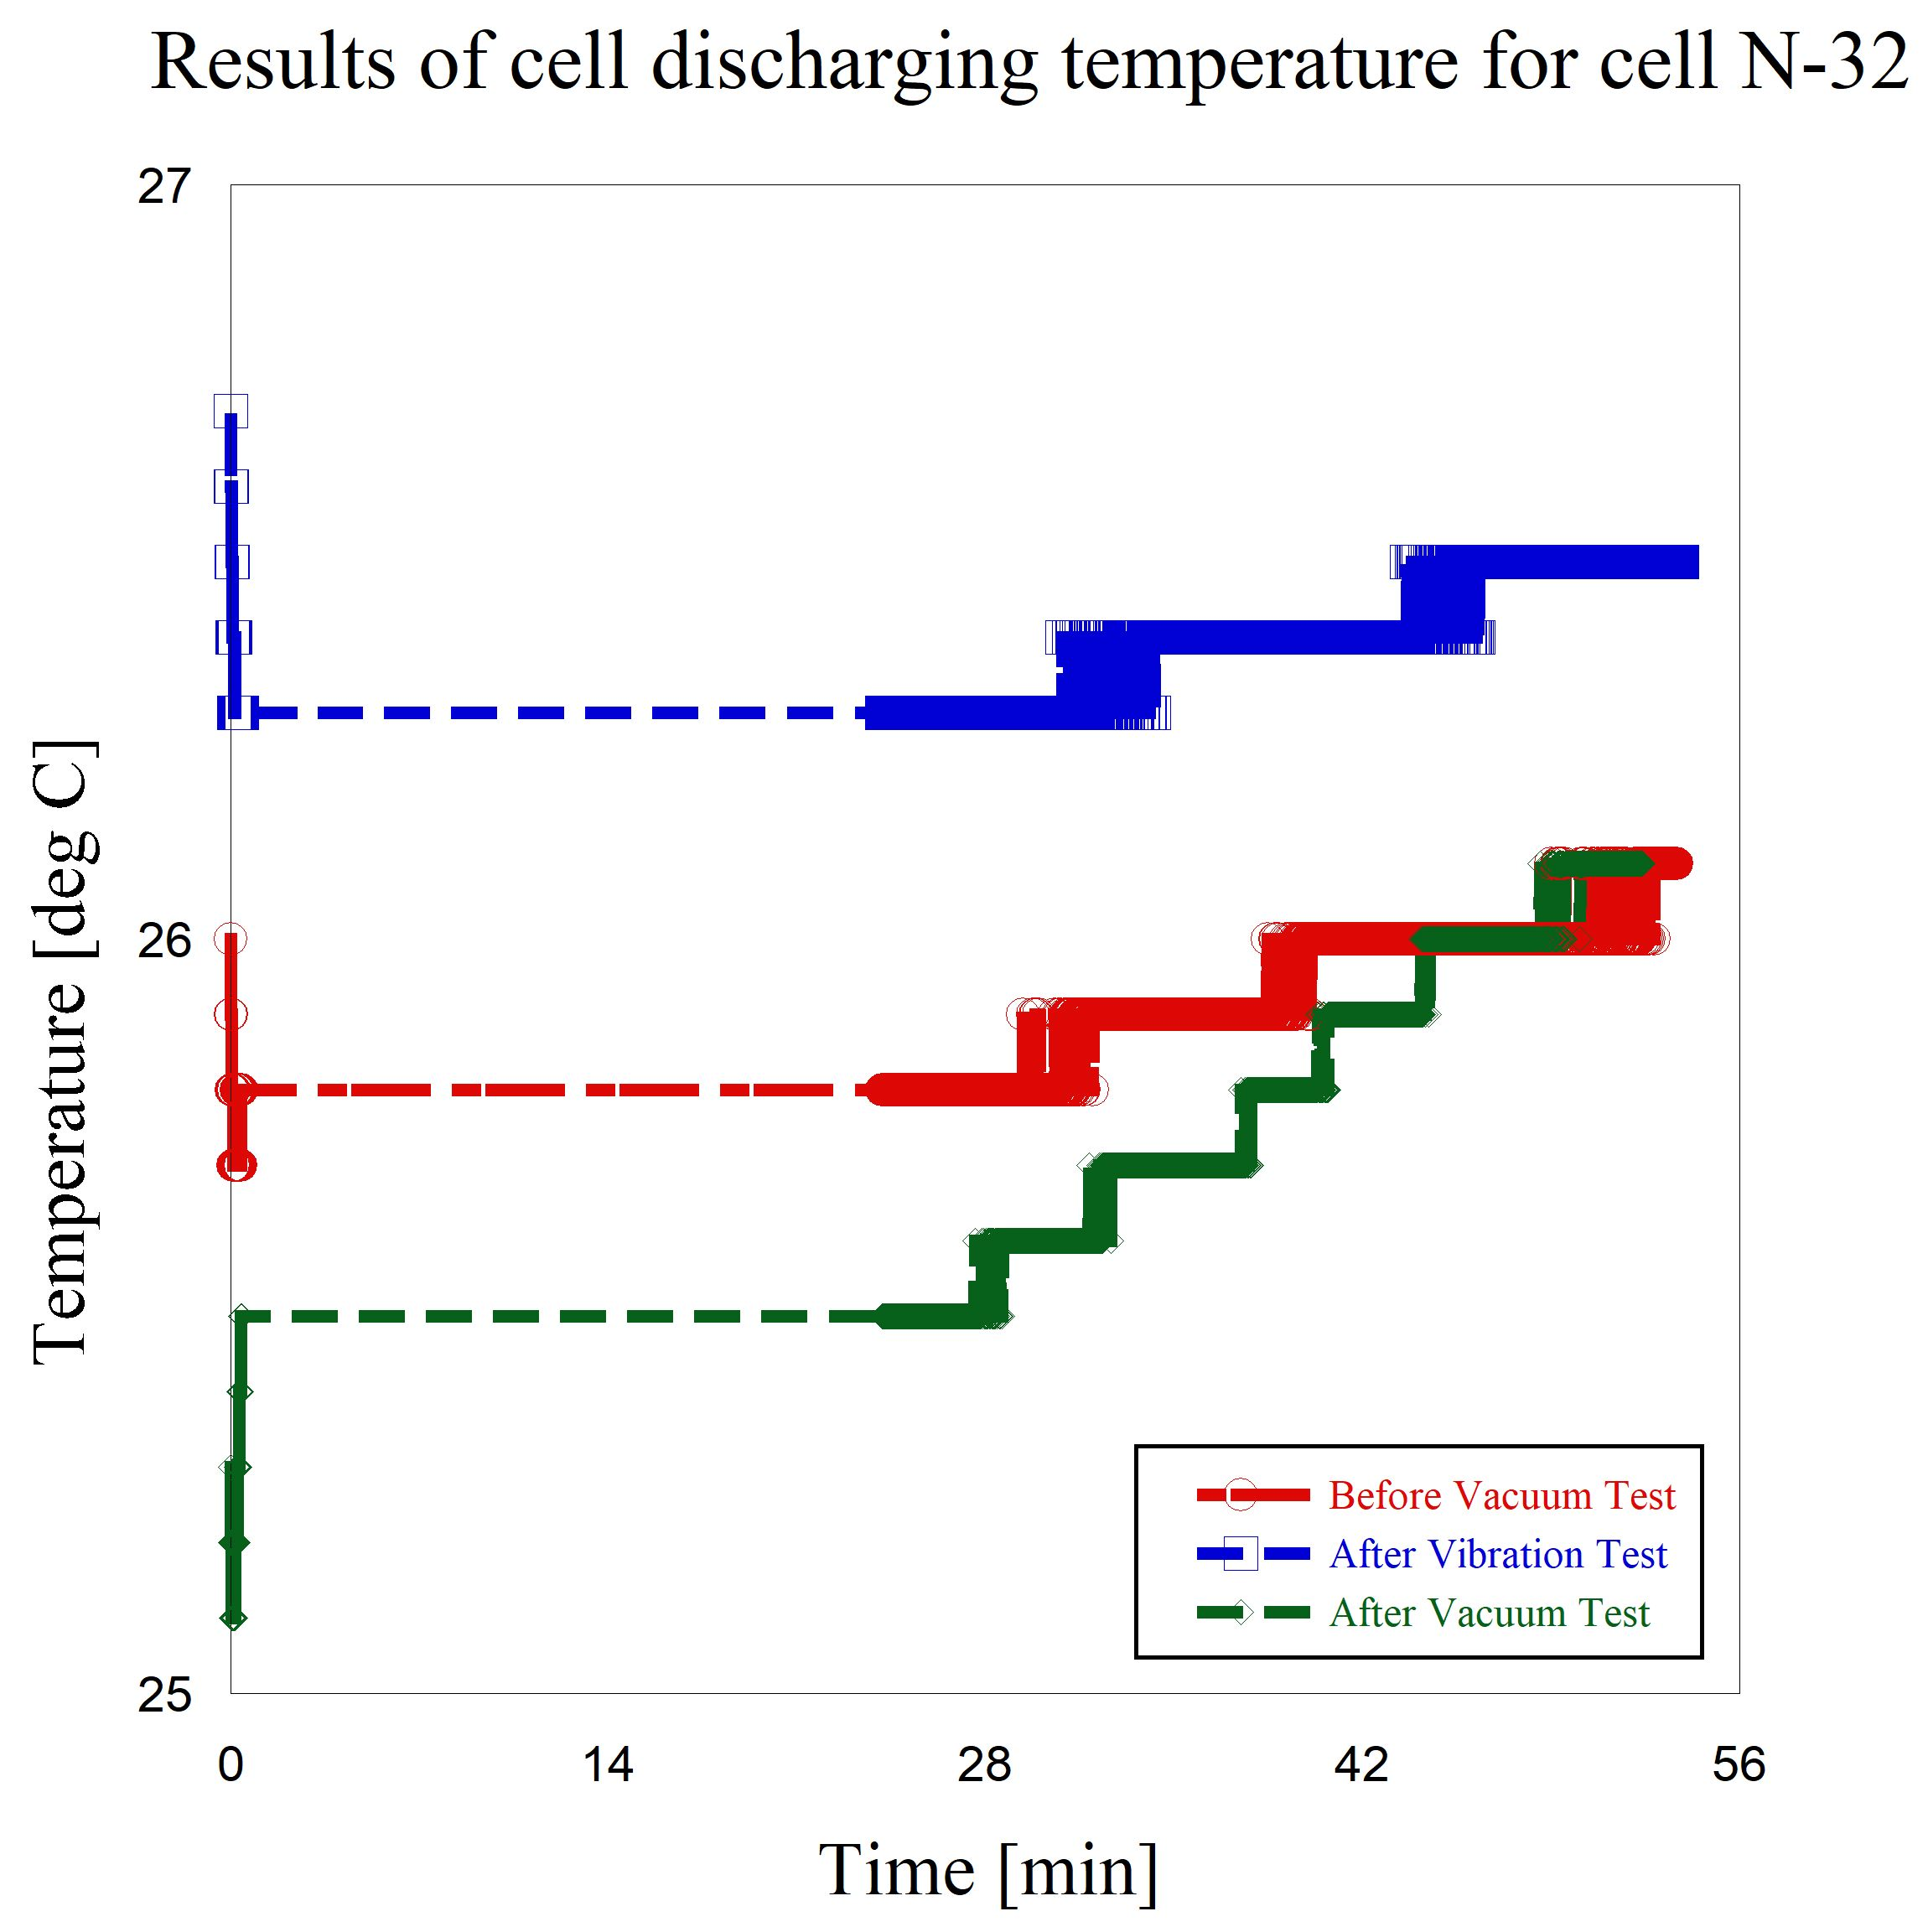

**Figure 7-35 Results of temperature at cell discharging (before & after) the vacuum test and after vibration test, cell N #32**

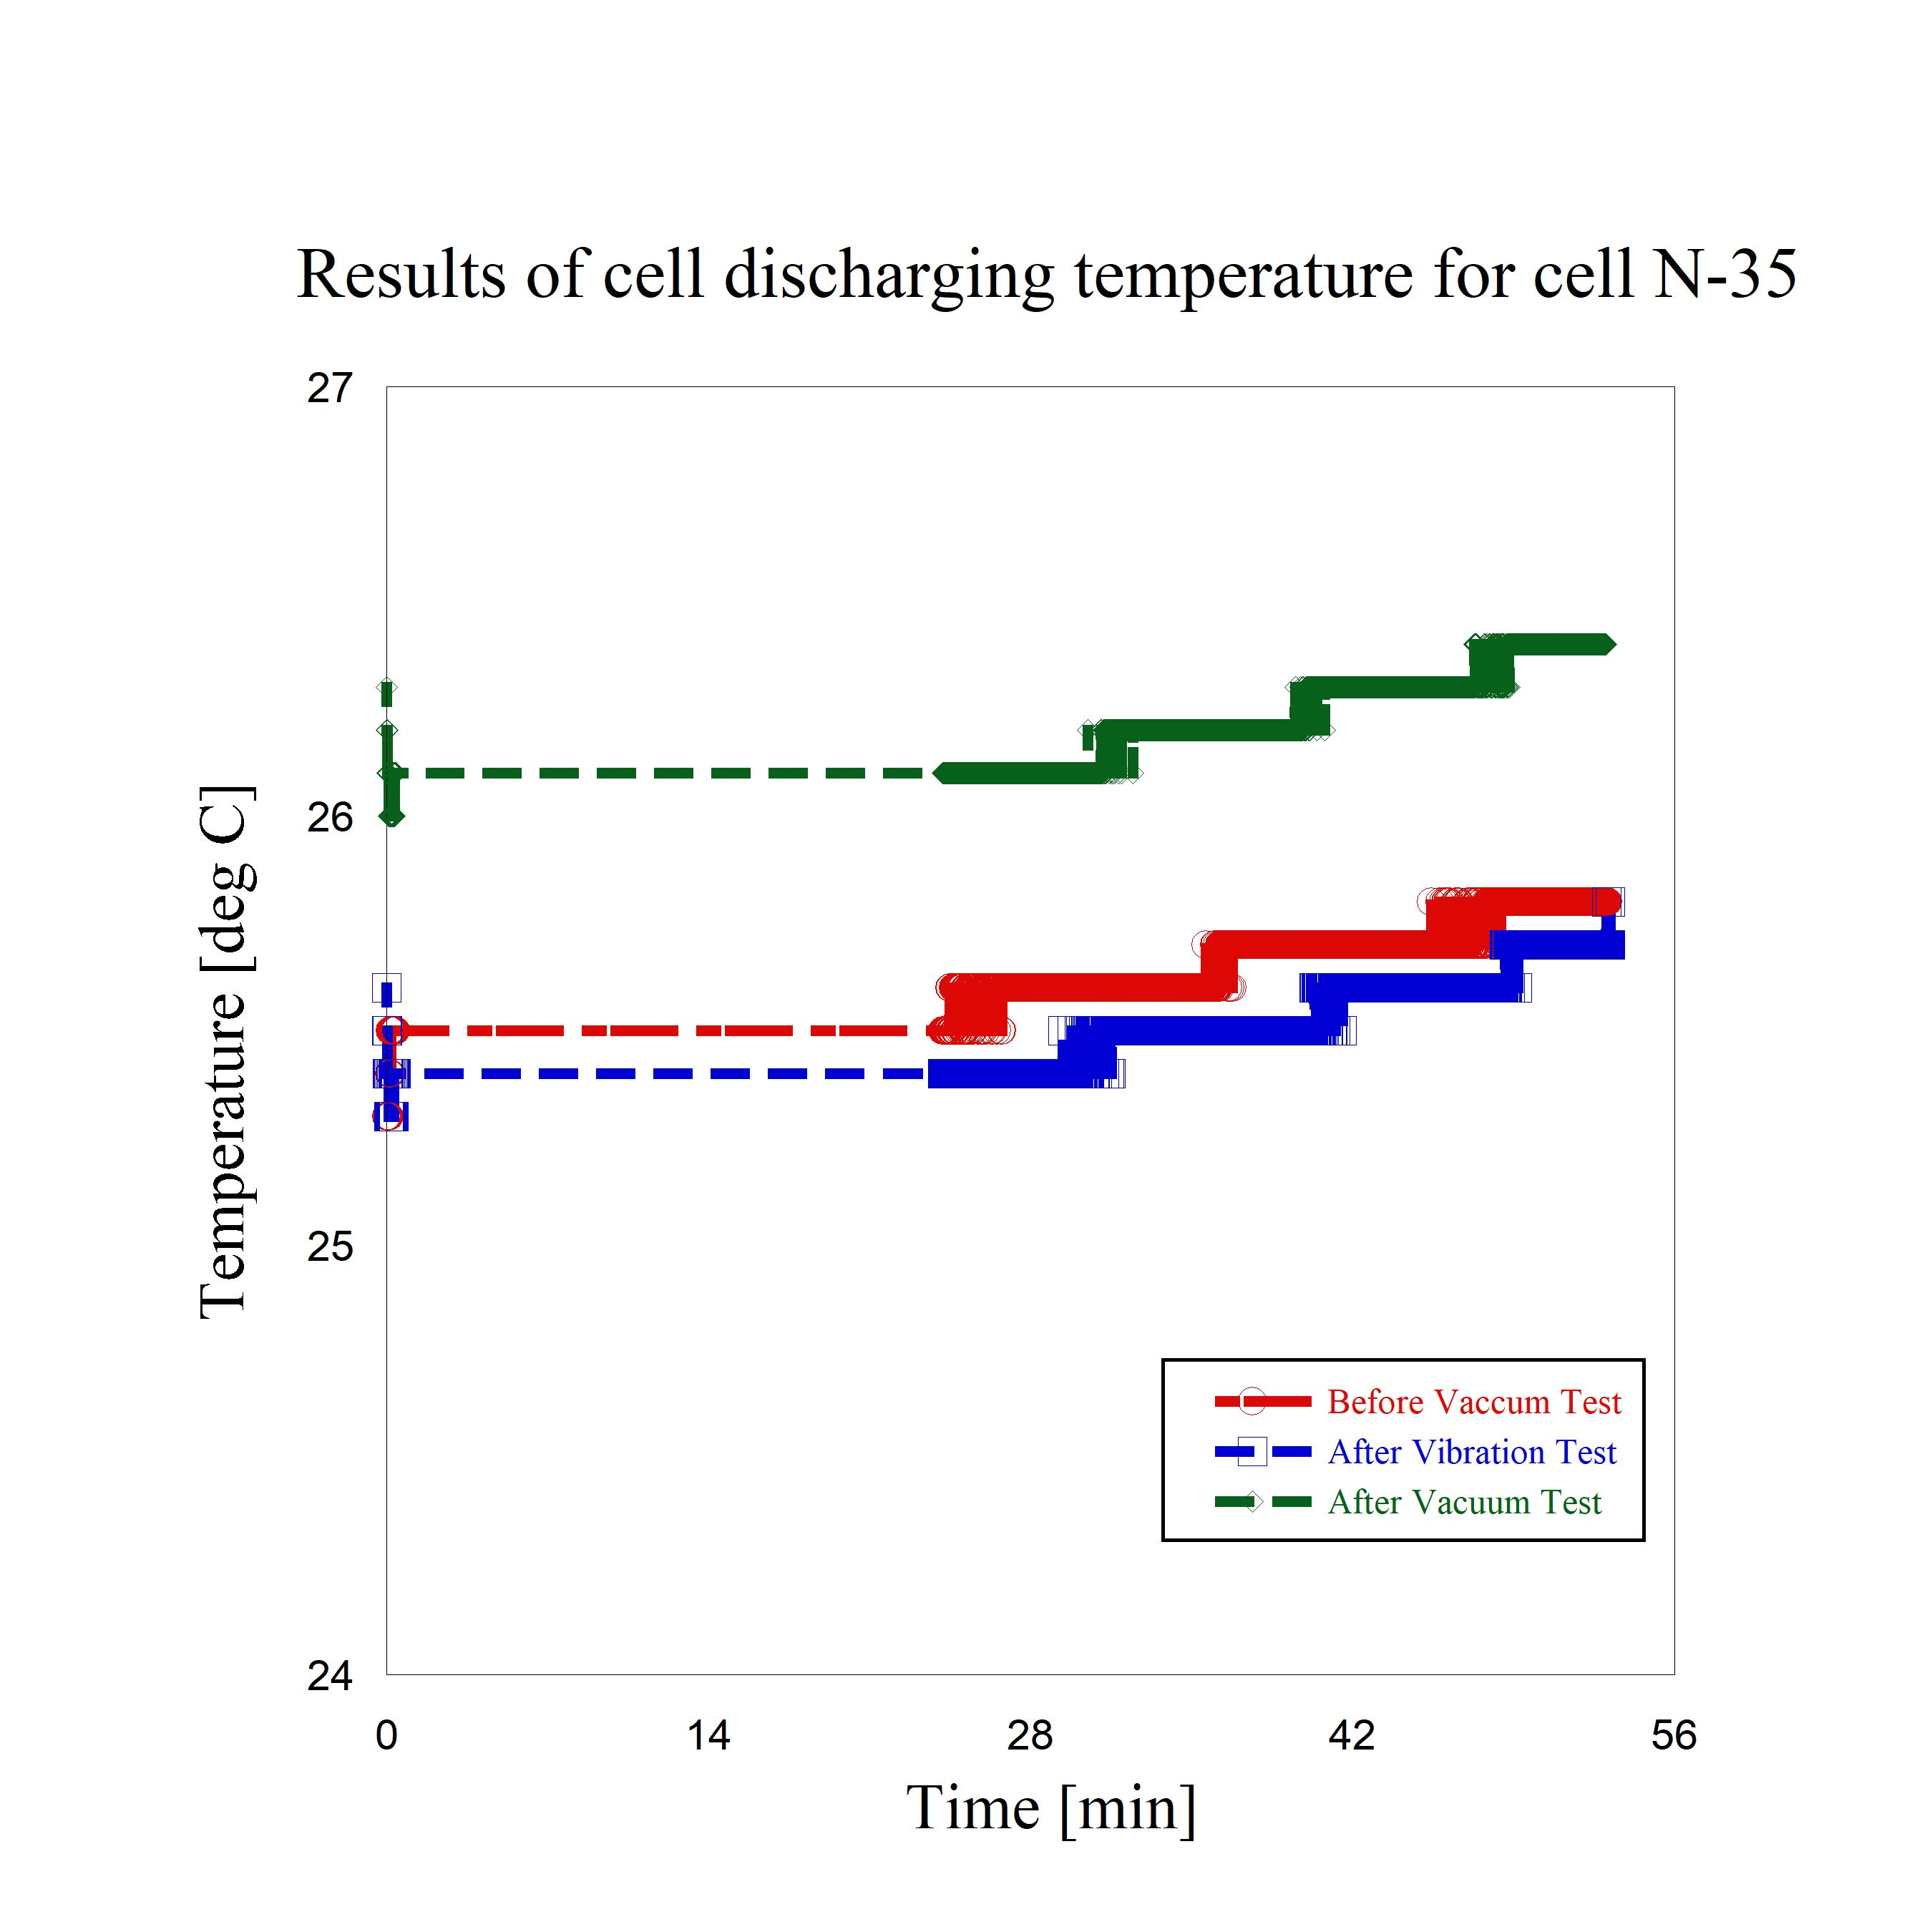

**Figure 7-36 Results of temperature at cell discharging (before & after) the vacuum test and after vibration test, cell N #35**

The followings results are the charge and discharge cycle results of the FM battery backup and cell discharging temperature curve.

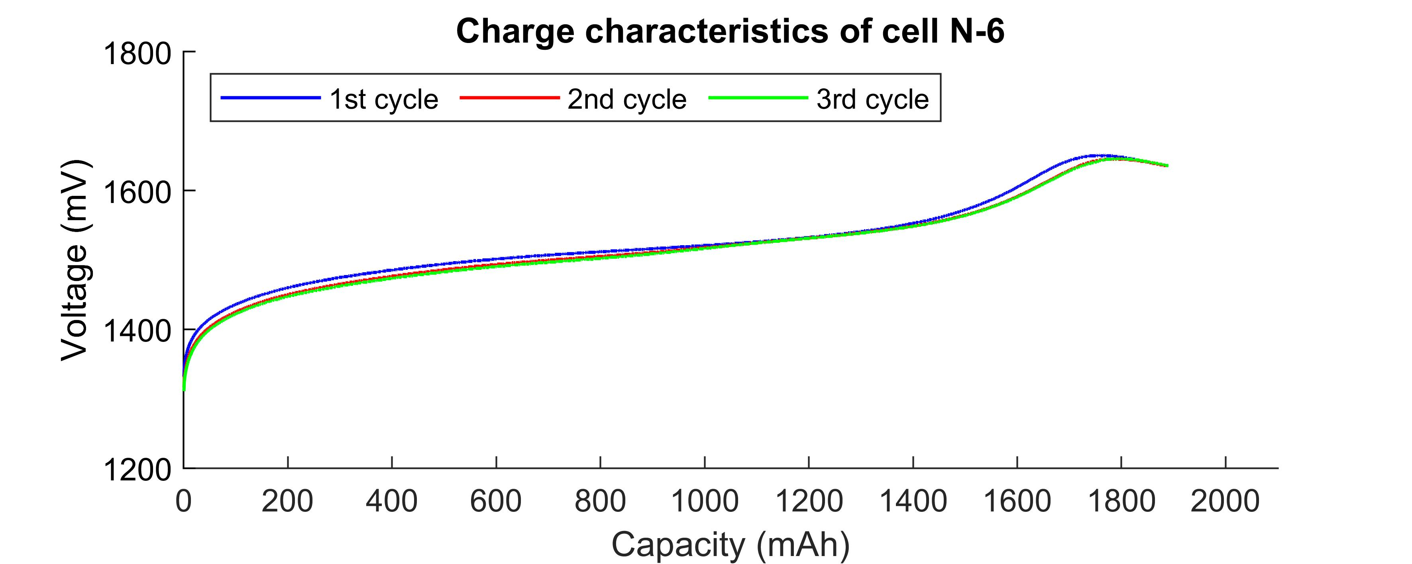

**Figure 7-36 Results of FM back up charging cell #6**

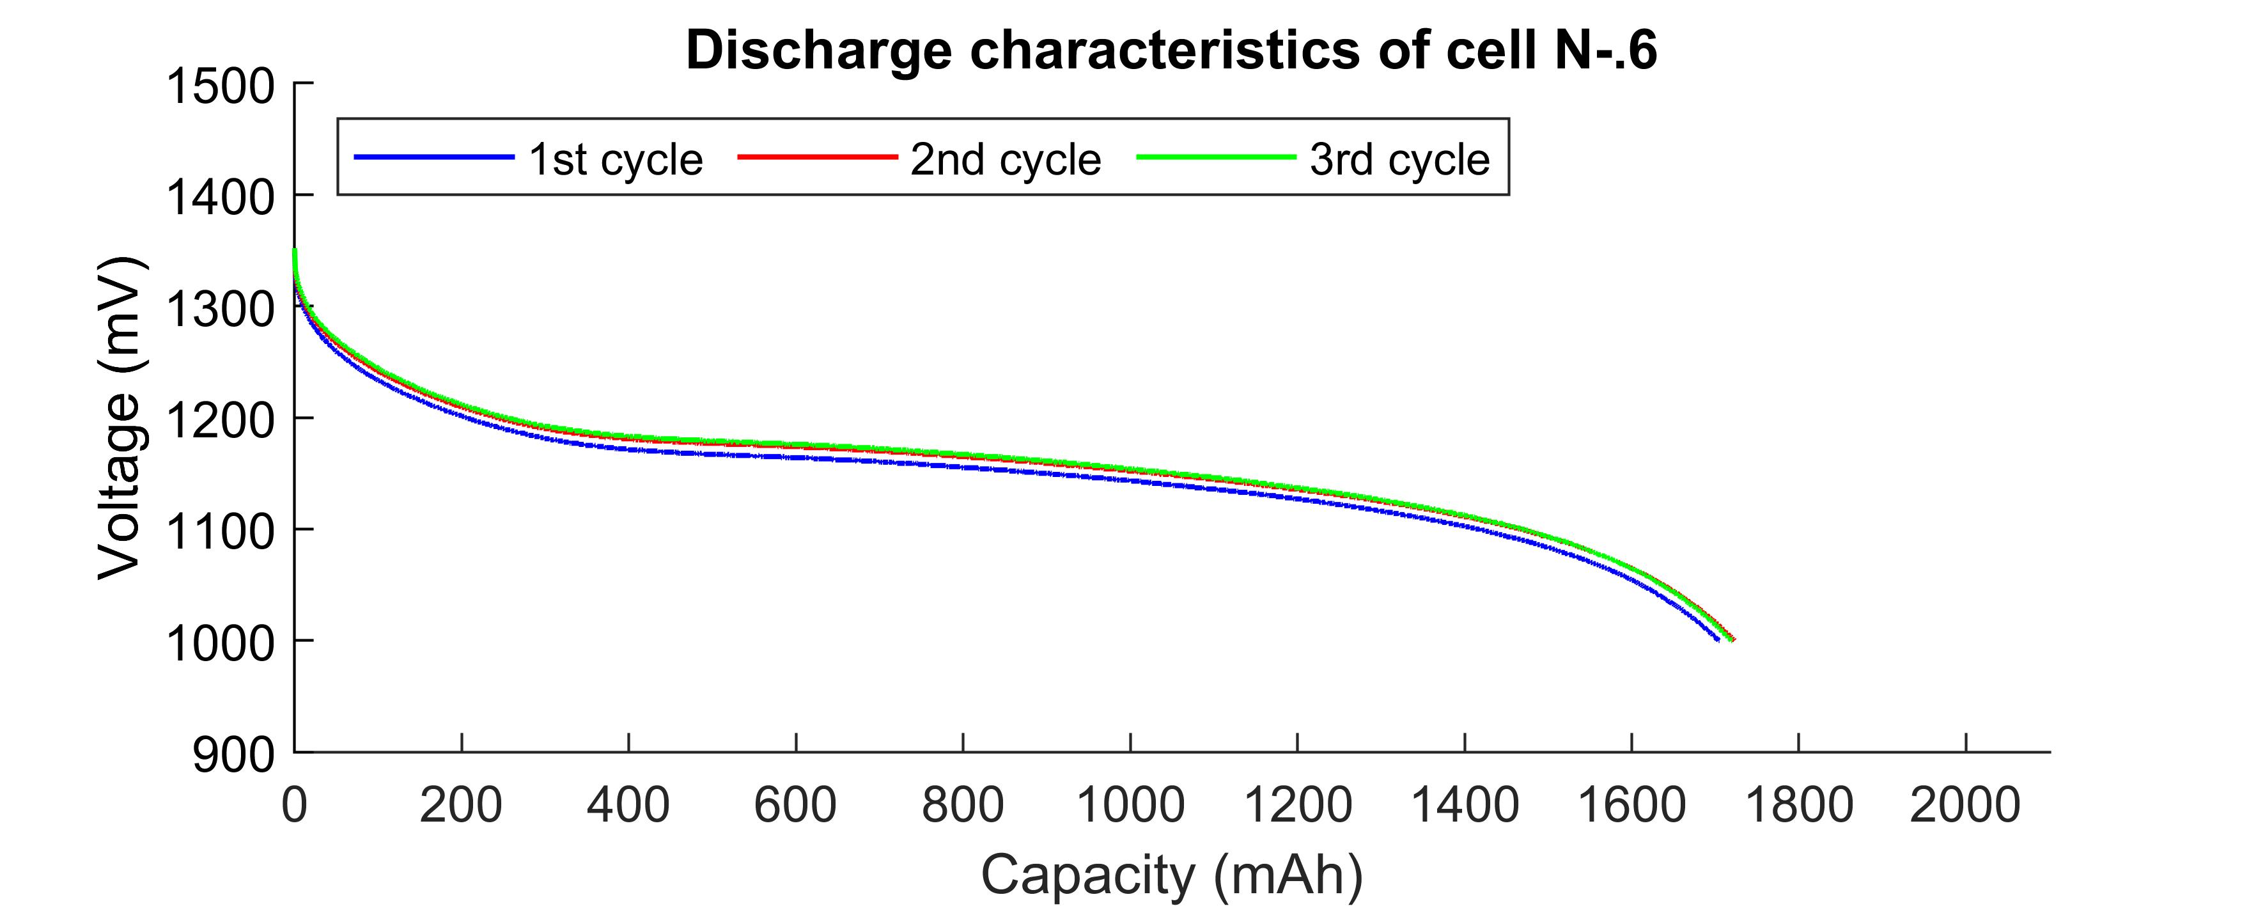

**Figure 7-37 Results of FM back up discharging cell #6**

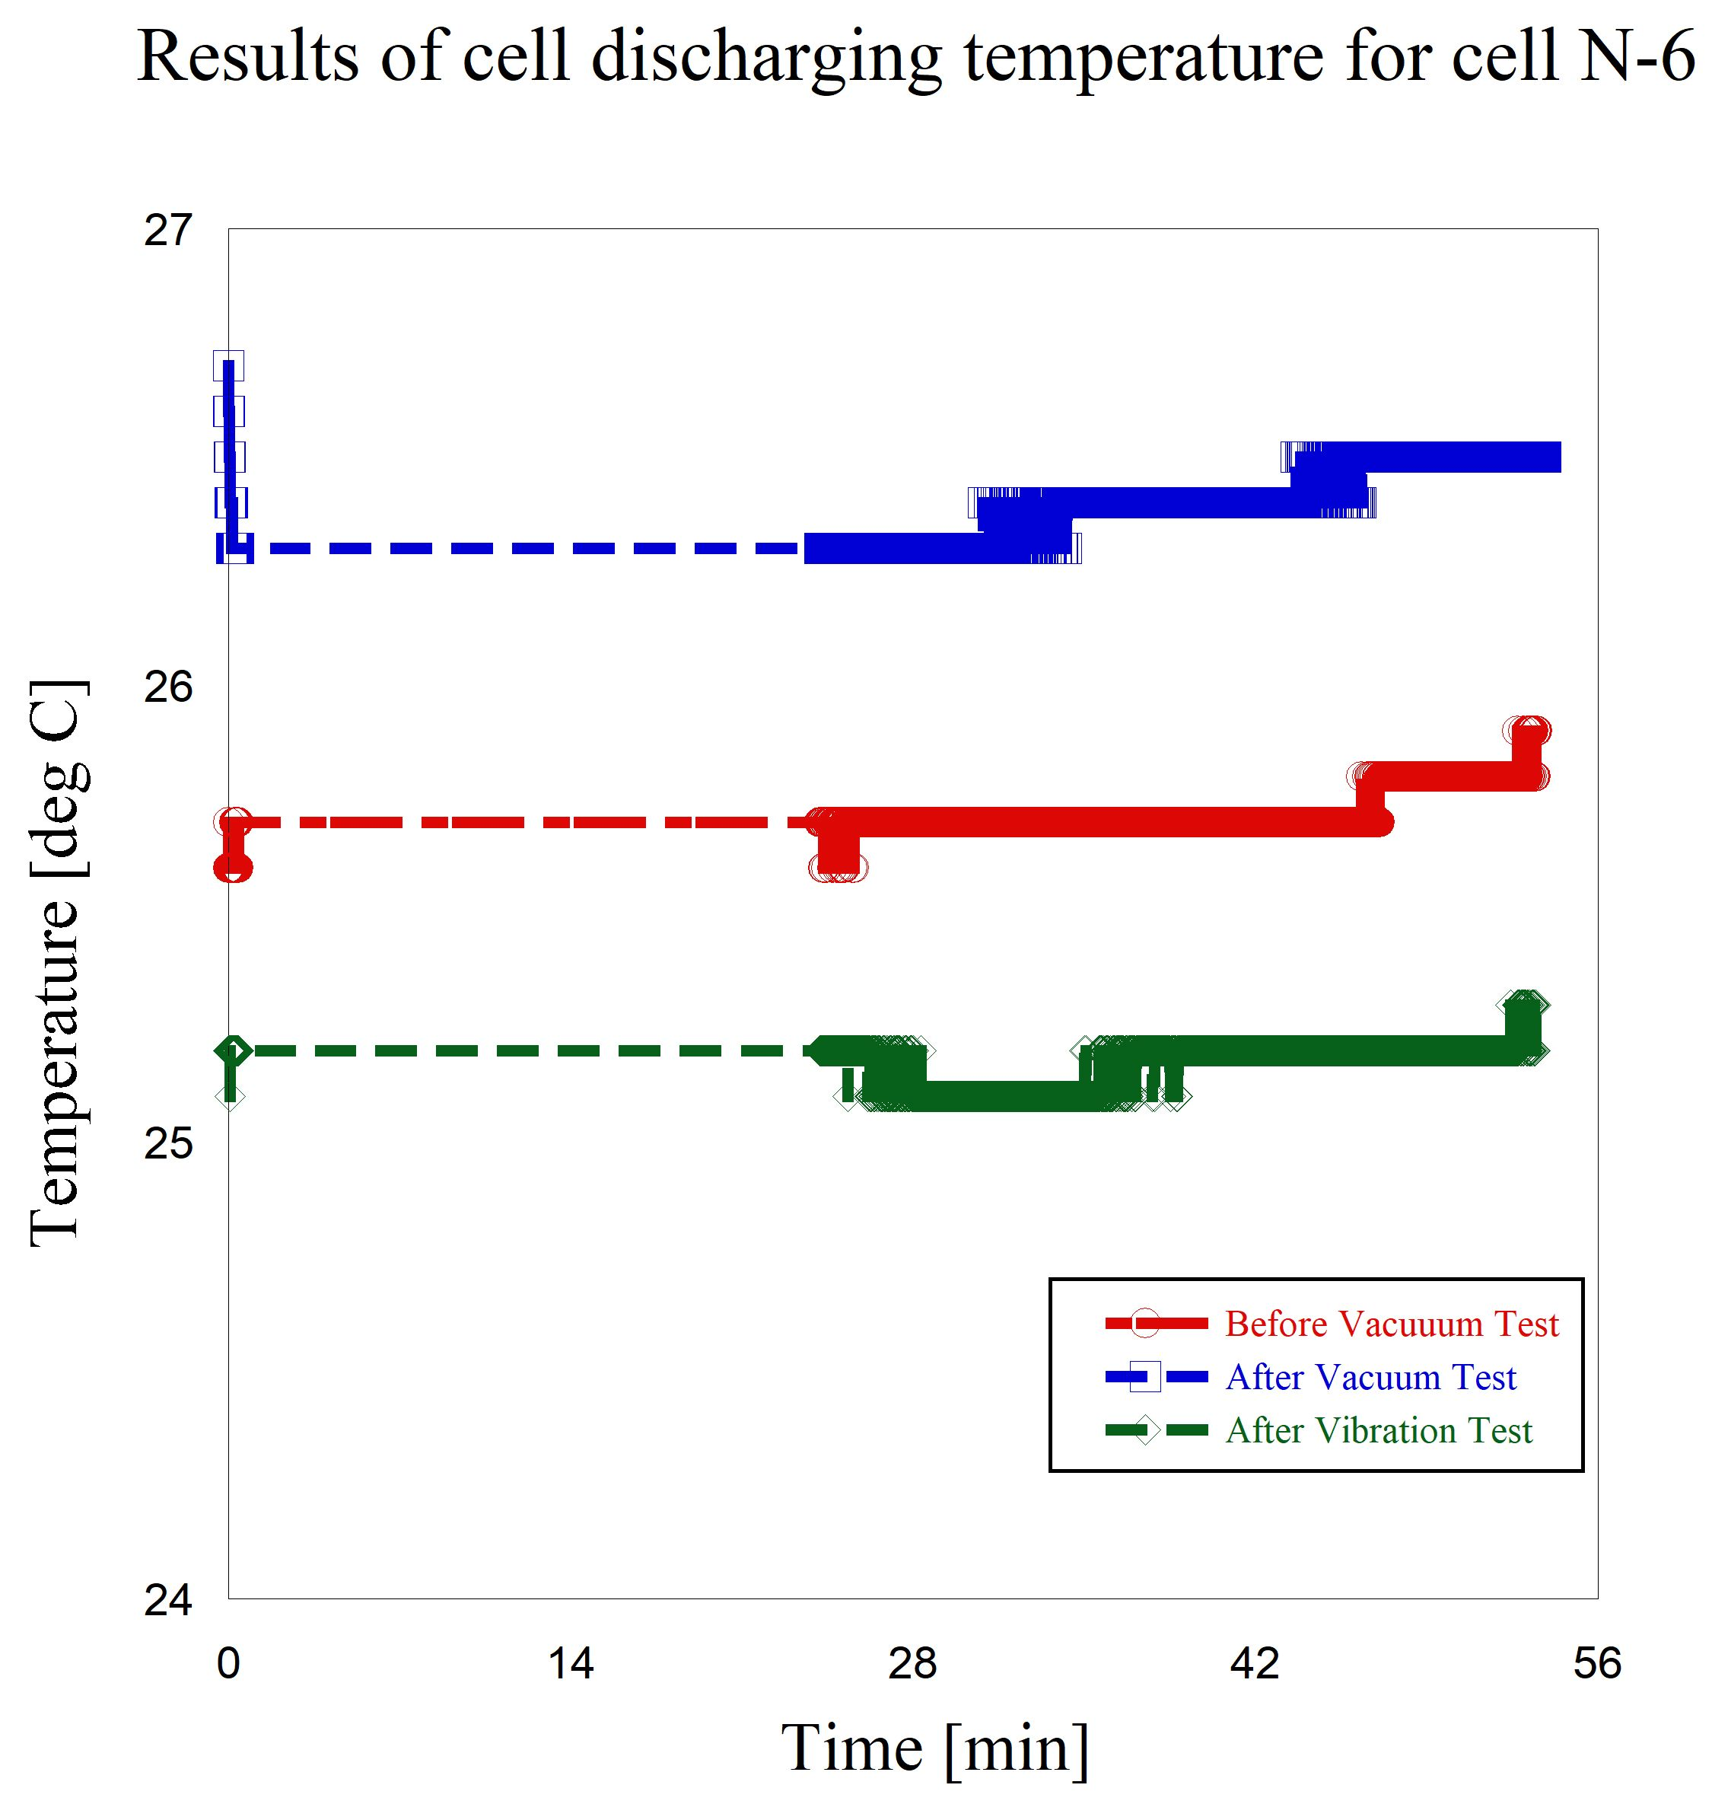

**Figure 7-38 Results of temperature at cell discharging (before & after) the vacuum test and after vibration test to FM battery backup cell N #6**

# Thermal Exposure Test

Thermal test of the battery cell of the same lot as the battery cell used for FM is performed for the confirmation of temperature tolerance. The test has been conducted for the temperatures between 60 °C to 65 °C for 2.5 hours (ref. Figure 8-1). The experiment set-up is given as Figure 8-2. This is the battery(cells) lot test. We used only two single cells into thermal environmental environment and maintain the constant high temperature without doing charging and discharging for flight module battery (cells). Before and after the thermal test, the results of functionality test were different as it could be seen from Table 8-1 showing the results of the test. The discharge test results are also given in Figure 8-3. A visual inspection has been also performed and the battery had no sign of a damage (no scratches, misaligned seals or an electrolyte leakage).

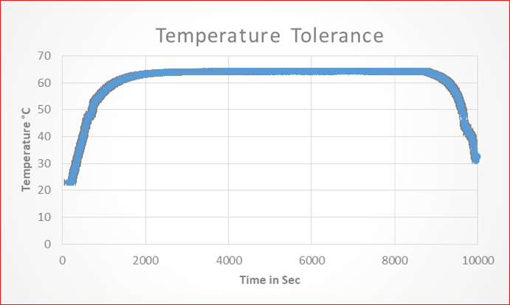

Figure 8-1 Thermal profile applied in the test

Table 8-1 Test results before and after the thermal tolerance test

|  |  |  |  |  |  |  |  |  |  |
| --- | --- | --- | --- | --- | --- | --- | --- | --- | --- |
| Battery No | Mass | | | OCV | | | Capacity | | |
| Before  [g] | After [g] | Change [%]*  (<0.1) | Before  [V] | After [V] | Change [%]*  (<0.1) | Before [Ah] | After [Ah] | Change [%]*  (< 5) |
| #36 | 25.82 | 25.82 | 0.00 | 1.35 | 1.34 | 0.07 | 1.798 | 1.800 | -0.11 |

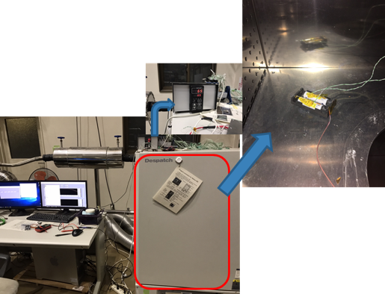

Figure 8-2 the experimental set up thermal tolerance set up at thermostatic chamber

Figure 8-3 Result of discharging after thermal test